**5**

**ORGANIC EVOLUTION**

**Chapter coverage**

5.1 *Introduction of organic evolution*

5.2 *Theories of origin of life*

5.3 *Theories of organic evolution*

5.4 *Evidences of organic evolution*

5.5 *The concept of speciation*

**5.1 INTRODUCTION OF ORGANIC EVOLUTION**

The term evolution was coined by **Herbert spencer** and has been derived from Latin word “*evolvere*“ which means “ unfolds“, That is; To understand the secrete of life. **Organic evolution** is a gradual development of more complex life forms from the pre-existing simple life forms over the course of time.

**Importance of organic evolution:**

The evolution process is very important in living organisms due to the following reasons:

* It result to the emergence of new species from pre – existing ones. This emergence of new species is called **speciation.**
* It helps to understand the origin of life on the earth and the mechanism which brought life on the earth.
* It results into the modification of some body structure of the organisms to match the needs of the environment.
* It result into modification of immunity system to increase the survival chance.

**SAQ 5.1**

**MBEYA MOCK 2018**

* What do you understand by the term organic evolution
* State three importance of organic evolution

**5.2 THEORIES OF ORIGIN OF LIFE**

Life has existed on earth for a very long time. Scientists think that the earth is about 5 000 000 000 years old and that life on earth began about 3 000 000 000 years ago. There is an estimated 4 Billion species in existence today. The question is; how did such tremendous diversity of life come to exist on this planet? There are five (5) main theories that have been put forward to explain the origin of life. They include **special creation**, **spontaneous generation**, **cosmozoan**, **steady state** and **biochemical theory**.

***Special creation theory***

This theory states that; “Life and all living organisms were created on the earth by the supernatural being called God“. The theory is based on the religious beliefs. For example, **In Christianity**, it is believed that, “God created this universe, plants and animals in six natural days“(*Genesis 1: 1 -*25), **In Muslims**, it is believed that, “God created heavens and earth in six distinct periods and Adam from a sounding clay“(*Quran; sura 7 verse 54*), **in Hinduism** mythology**,** it is believed that; “The God called Brahma created the living word in accordance to his wish”. The theory also suggested that, the species once created, remain unchanged.

**Strength of special creation theory**

* The theory opened up the minds of scientists to argue on the origin of life on earth.

**Weaknesses of special creation theory**

* The theory cannot be proved experimentally.
* The species never remain unchanged due to adaptations to the changing in the environment.
* The theory disobeys the law of biogenesis as it stresses that, life can arise from a word or from nothing provided that there is Gods will. According to the law of biogenesis, life originates from the pre-existing life.

***Spontaneous generation theory***

This theory states that; “Living organisms arose spontaneously from non-living matter on various occasions“, such a hypothetical process by which life arose from non-living matter over specific periods of time is known as **abiogenesis**, which means life comes from non-living things.

The theory was prevalent in ancient Chinese, Babylonian and Egyptians thought as an alternative to special creation. For example; **Egyptians**, believed that the mud of River Nile could give rise to many forms of life such as crocodiles, frogs and snakes. The **Greek philosopher Aristotle**, on the other hand, believed that, dead leaves falling from a tree into a pond would transform into fishes. Aristotle postulated that certain particles of matter contained active principles, which could produce living organisms under favourable conditions. The active principles were in fertilized eggs, seeds, sunlight, mud and decaying meat.

**Strength of spontaneous generation theory**

* The theory opened up the mind of scientists to argue on the origin of life.
* The theory can be proved experimentally.

**Weaknesses of the spontaneous generation theory**

* The theory disobeys the law of biogenesis as it stresses that, life can arise from non-living matter. The theory of spontaneous generation was disproved in the course of time following the experiments conducted by Francesco Redi (1668), Lazaro Spallanzani (1765) and later Louis Pasteur (1860) in his famous swan neck experiment. They come out with the theory of biogenesis, which states that “Living things only come from other living things through reproduction“.

**Redi’s experiment Francesco Redi** (Italian physician) took the flesh and cooked meat so that no organisms were left alive. He placed the flesh meat in three jars (Fig 5.01). He left the first jar uncovered, the second jar was covered with fine parchment and the third was covered with fine muslin. In a few days, maggots which are larvae of houseflies appeared in the first jar, none in the second and third jar, although plenty of flies alighted on the muslin cloth covering the third jar. From this Redi concluded that the maggots that appeared on the decaying meat were introduced from the outside by the houseflies which laid eggs on the meat but not spontaneously from the decaying meat itself.

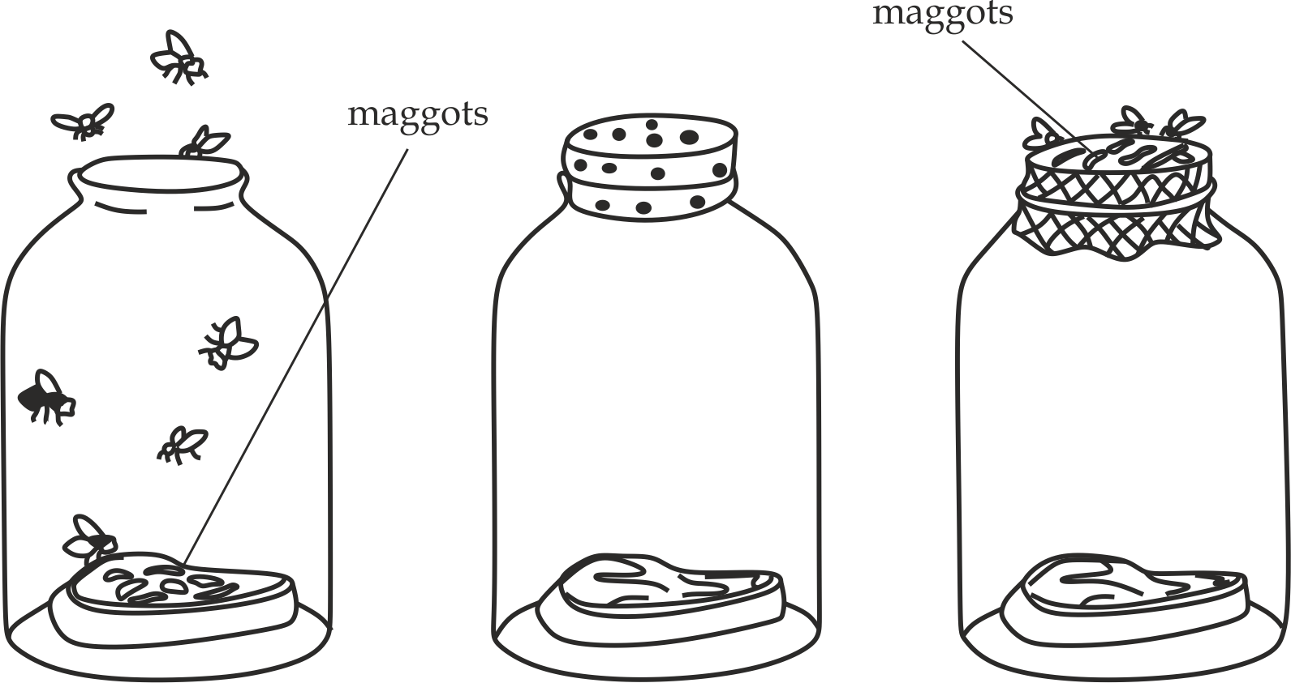

**A B C**

**Fig 5.1** Redi’s experiment to disprove abiogenesis. **A**. Uncovered jar, **B**. Jar covered with parchment**, C**. Jar covered with muslin.

***Cosmozoic/ panspermia theory***

The theory states that; “Life arrived on the earth planet from elsewhere else in the universe by some means“. This means that life did not originate on the earth, rather, it originated somewhere in the galaxy and it was brought on the earth planet as a ready-made material. This theory therefore does not offer a mechanism that account for the origin of life but favours the idea that it could have had an **extra-terrestrial** origin.

Some evidences have been used to show how life could have arrived on the earth from elsewhere. For example, repeated sightings of unidentified flying objects (UFOs), cave drawings of rockets like objects and “spacemen“ and reports of encounters with aliens, provide evidence of the arrival of life on the earth from elsewhere,

**Strength of the cosmozoic theory**

* It is true that life is supported on the earth.

**Weaknesses of the cosmozoic theory**

* The theory does not tell the mechanism through which life was brought onto the earth.
* The theory cannot be tested experimentally or scientifically.
* The theory does not the origin of life on the earth, and therefore, it does not deserve to be called the theory of the origin of life.

***Steady state theory***

The theory states that; “Life had no origin but it is supported on the earth“. Thus, the living organisms had no origin, they always change their numbers by increasing or decreasing or they become extinct. The theory does not accept the **paleontological evidence**, it assumes that the presence or absence of fossils cannot indicate the origin or extinction of the species.

**Strength of the steady state theory**

* It is true that earth slightly changes and life is supported on the earth.
* It is supports the law of biogenesis that life come from pre-existing life.

**Weaknesses of the special creation theory**

* It is not true that life had no origin; there should be origin of life.
* It is not true that paleontological studied have no contribution on the study of existence or extinction of the species.

***Biochemical (naturalistic) theory***

This is the modern concept about the origin of life on the earth which states that; “Life arose on the earth according to physical and chemical laws”. This origin of life by means of chemical evolution was explained by Russian scientist **Alexander Oparin** in 1924 and **J.B.S Halden** in 1929.Oparin theory was published in his book in 1936, ***the origin of life***.

According to Oparin; the primitive life originated in the water bodies on the primitive earth from non-living organic molecules (eg; RNA, proteins) by chemical evolution through a series of chemical reactions about 4 billion years ago. The main ideas on the mechanism of chemical evolution by Oparin include the following:

* **The condition of early atmosphere** on the primitive earth 4 billion ago contained hydrogen, oxygen, nitrogen and carbon element under high temperature (4000 to 9000 º C), this high temperature did not allow the formation of chemical bonds between these elements, and therefore, they existed as atoms.
* **As the earth cooled down** (less than 100 º C), the chemical bonds were formed between the atoms and the molecules were formed, Hydrogen being active and abundant, readily combined with other atoms to form nitrogen in the form of ammonia (- NH3), carbon in form of methane (- CH4) and oxygen in form of water vapour (-H2O), there was no free molecular oxygen, and therefore, the earth had a reduced atmosphere.
* **As the temperature of the earth cooled down further** (50 º C – 60 º C), water vapour condensed into liquid and very heavy rains, which were accompanied by lightning. This resulted in the formation of lakes, rivers and great oceans on the earth surface.
* **Formation of simple organic compounds**. The rain water dissolved methane, ammonia and carbondioxide using high energy from ultra violet radiations from the sun and electrical energy produced during lightning result into the formation of simple organic compounds such as sugars, fatty acids, glycerol, amino acids, purines and pyrimidine’s.
* **Formation of complex organic compounds.** Simple organic compounds underwent various chemical reactions and polymerization to form complex compounds like polysaccharides, fats, nucleotides and proteins.
* **Formation of protobionts.** Aggregation of proteins form microspheres and aggregation of lipids result into coercevarates which are all precursors of cells collectively called protobionts.
* **Formation of eubiont.** The combination of nucleic acid and protobionts form the first primitive cell called eubiont such as chemoheterotrophs. And hence come the origin of life.

**Strength of biochemical theory**

* It is scientific and therefore; it can be experimentally tested.
* The theory recognizes the role of amino acids and proteins in forming the basis of life.
* The theory encourages critical thinking and enhances inquisitive mind.

**Weakness of the biochemical theory**

* The theory fails to explain the transition from complex organic molecules to living organisms.

**SAQ 5.2**

**NECTA 2018**

* Name three theories of origin of life.
* Explain the origin of life based on the theories named (a) (i)

**5.3 THEORIES OF ORGANIC EVOLUTION**

There are three (3) main theories that explain the mechanism by which organic evolution operates, these include **Lamarck’s theory**, **Darwin’s theory** and **Neo Darwinism theory**.

***Lamarck’s theory of evolution***

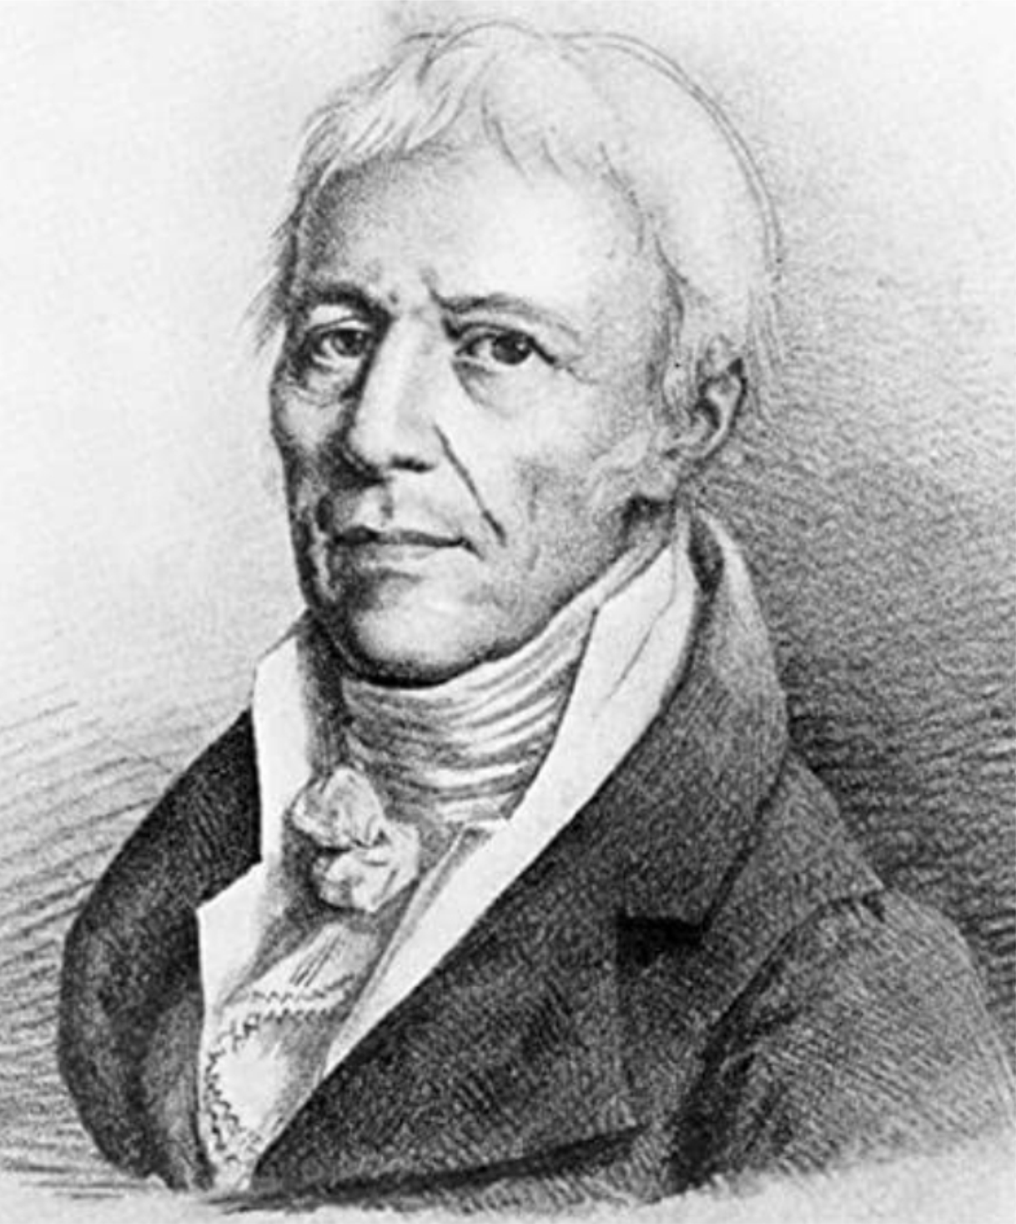

**Fig 5.2** Jean B Lamarck in 1809

FigF

**Jean Baptise de Lamarck** was a French biologist who lived between 1774 to 1829 years (Fig 5.2). In 1809, he proposed a theory to account for the mechanism of evolution on his book “Philosophic zoologique” based on the following three main postulates:

* *The effect of environment change*
* *The use and disuse of organ*
* *The inheritance of acquired character*

**The effect of environment change**

The chance in the environment may lead to the change in the pattern of behaviour of an organism to cope with environment.

**The use and disuse of organ**

If the body organ is constantly used, it will become strong and better developed, and if the organ is not used, it will become weak and disappear.

**The inheritance of acquired character**

The acquired character during the life time can be passed from one generation to another.

**SAQ 5.3**

**JOINT DAR SCHOOLS – 2021**

* Briefly explain main three ideas of Lamarck’s theory of organic evolution.

In an attempt to back up his theory, Lamarck used the following examples – development of long neck and legs of modern giraffe’s, development of webbed feet in modern ducks, and development of flat shaped fish.

1. **Development of long neck and legs of modern giraffes** (Fig 5.3)

According to Lamarck, ancestral giraffes had short necks and forelimbs. They lived on grassland and fed on grasses. Gradually environment conditions changed, climate became dry, grassland transformed into desert and leaving behind few tall trees. For survival giraffes had to stretch the muscles of their necks and forelimbs in order to feed on the leaves of tall trees. Due to continuous stretching, the length of the neck and forelimbs increased. The increase in length of the neck and forelimbs was acquired character which passed from generation to generation as the result the modern giraffes have long neck and fore limbs.

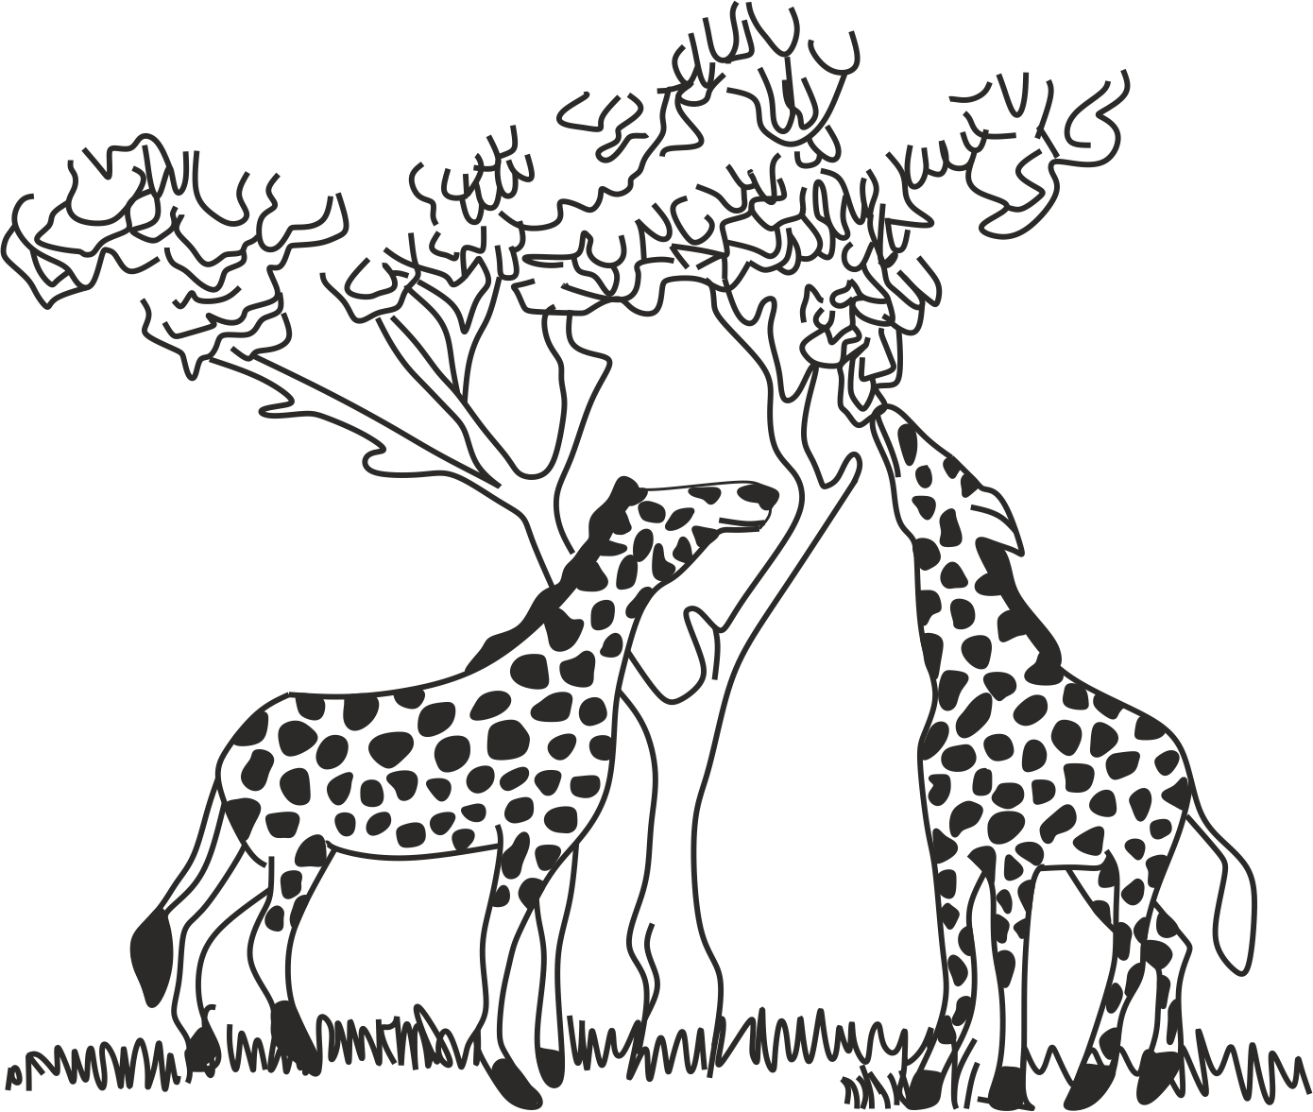

**Fig 5.3 a**

Ancestral giraffes had short necks probably were subjected to frequently stretching to enable the giraffes to reach the foliage leaves.

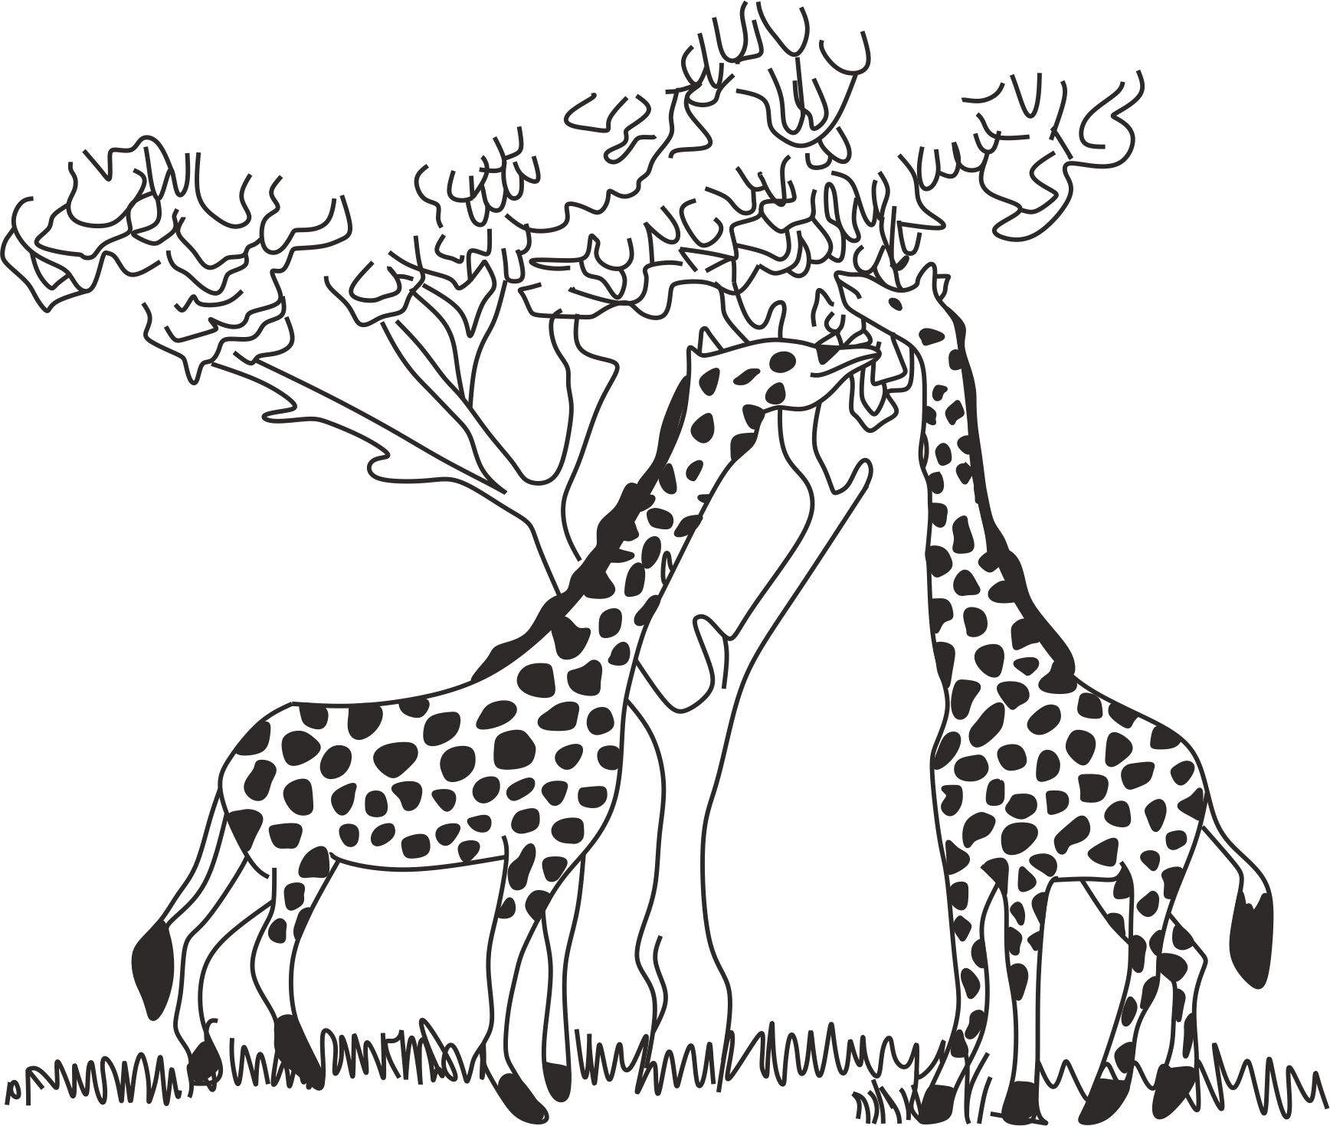

**Fig 5.3 b**

Eventually the continued stretching of the neck gave rise to the modern giraffes

**Fig 5.3** development of long neck of the giraffes by Lamarck

1. **Development of webbed feet in modern ducks**

According to Lamarck, ancestral ducks had no webbed feet and they fed on the land. Gradually environmental conditions changed, the food became scarce on the land and leaving food in the water only. For survival ducks were forced to search food in the water by stretching their toes to achieve maximum and efficient swimming. Due to continuous stretching, the skin between their toes became stretched to form webbed feet. According to this theory, the webbed feet was acquired character which passed from generation to generation as the result the modern ducks have webbed feet.

1. **Development of long slim body in snakes**

Lamarck believed that, previously snakes had four limbs like lizards and fed on open space, when faced the problem of increased predation, the lizard – like ancestral snakes started crawling on the ground into crevices and holes in order to protect themselves. To accommodate their bodies in such narrow space they could not use their limbs for locomotion, continuous disuse of limbs resulted in limbs becoming shorter and finally they disappeared from generation to generation.

**SAQ 5.4**

**DAR MOCK 2021**

* Describe any three examples used by Lamarck to justify his theory of organic evolution:
* Development of long necked and tall legged giraffes.
* Development of webbed feet ducks.
* Development of long slim body in snake.
* Development of flatfish.

**Strength of Lamarck’s theory**

* The theory opened up the mind of different scientists to discuss about the organic evolution. For example, the scientist like Gregor Mendel worked had to find out the origin of species and causes of organic evolution.
* The theory recognizes the role of environment in evolution. For example, the environment plays an important role in producing a phenotypic change of an organism as in case of body building exercises, which increase the size and strength of the body muscles.

**Weaknesses of Lamarks theory**

* The use and disuse of the body organ cannot determine its existence.
* The theory did not distinguish between inheritable and non-inheritable characters.
* The theory did not explain the role of genetic variation.
* The acquired trait is phenotype, hence cannot be transmitted from one generation to another since it is not part of hereditary materials, **Weismann** concluded that only genotype can be inherited i.e. Genes are not changed by muscular activity. Do you think the man in Fig 5.4 will have children with muscular bodies?

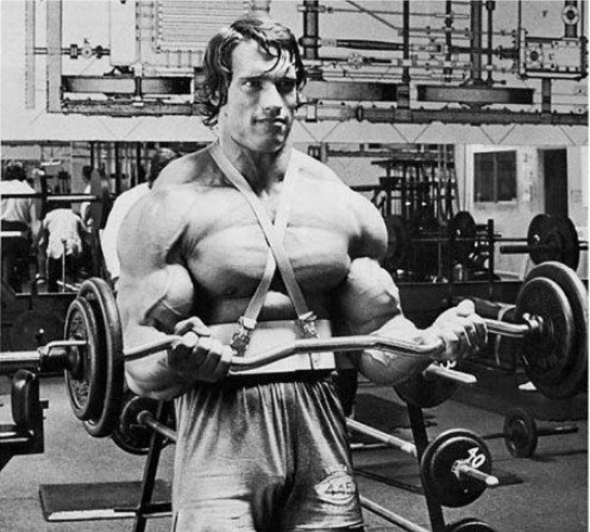

**Fig 5.4**

This man has lifted weights to change the shape of his body. Do you think he will pass these traits on to his children?

**SAQ 5.5**

**DAR MOCK 2007**

* What are the useful contribution of Jean Lamarck in the study of evolution?
* Give four reasons as why almost all biologist reject Lamarck theory at the time it was published.
* What did Weismann conclude after his experiment of breeding mice and cutting their tails over successive generations?

Did ***you know?***

***Did you know?***

Upon rejection of his theory of evolution Lamarck decided to study about invertebrates, a study which made a great contribution in the development of zoology.



***Darwin’s theory of evolution***

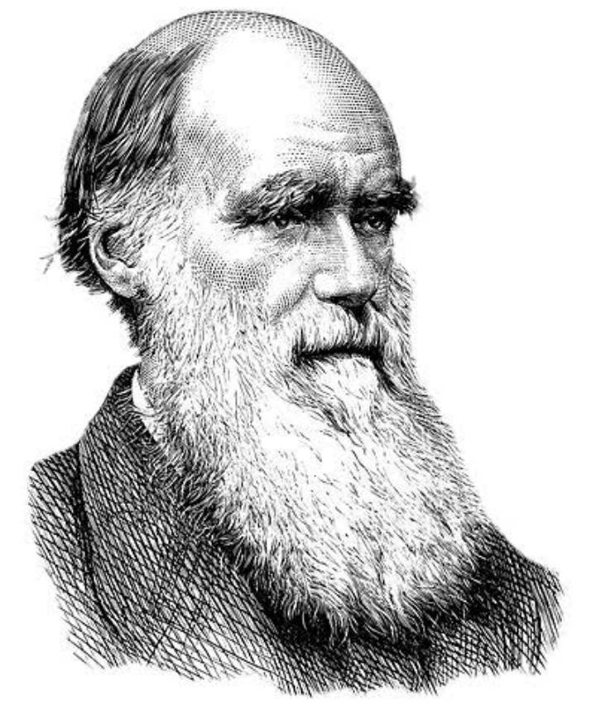

**Fig 5.5** Charles Darwin 1809 - 1882

***Charles Robert Darwin*** was an English biologist who lived in between 1809 – 1882(Fig 5.5). Beginning December 27, 1831 Darwin made a Journey of five years from south America to various parts of the world using his ship called HMS Beagle, during his five years voyage, he made several observations and collected various specimens of plants and animals. More importantly, he stayed five weeks on the Galapagos Island where he was interested in the characteristics of species of tortoises and finches.

In November 1959, Darwin published his theory in the form of a booklet entitled “Origin *of species by means of natural selection* “. Similar observations were made by Alfred Russell Wallace, hence, a new theory was published by the name of Darwin – Wallace theory. This is known as the theory of natural selection. The mechanism of evolution according to Darwin – Wallace theory by natural selection is based on three (3) observations and two (2) deductions:

**Observation 1: Overproduction of the offspring**

Individuals within a population produce more offspring than the environment can support. On average, they produce more offspring than they are needed to replace them.

**Observation 2: Constancy in the population size in each species**

Despite the high rate of reproduction among the individuals in a population, the number of individuals in each given population tends to remain fairly constant.

**Deduction 1: There is struggle for existence**

Darwin and Wallace concluded that, over reproduction results in a severe competition among individuals for the limited resources such as food, space, and mate. This competition between individuals for the limited resources is called struggle for existence. During the struggle, many organisms fail to either reproduce or die before reaching the reproductive age, this explains why the population size tends to remain approximately constant.

**Observation 3: Variations exist within all population**

Darwin observed that variations exist within all population. During competition every individual tries to become better adapted than the other by utilizing the resources in order to survive successfully. For this reason, variations start to arise in the organisms.

**Deduction 2: Natural selection or survival for the fittest**

In the course of struggle for existence only those organisms with favourable adaptive variations have a reproductive rate advantage and high survival chance (This is called a selective advantage). Those with unfavourable variations have limited chances in the struggle for existence, and therefore, they perish. Thus, Darwin concluded that, nature selects only those organisms which carry favourable traits with better adapted to their environment and can transmit their traits to their offspring. **Hebert spencer** called this concept “*survival* *of the fittest*“; the term means the well adapted organisms to the environment will survive and pass the traits from one generation to another as the result new species origin by natural selection.

**SAQ 5.6**

**MTWARA AND LINDI MOCK 2021**

* Summarizes the Darwin – Wallace theory of natural selection based on three observations and two deductions.

**Summary of six essential features of Darwin theory by natural selection:**

1. **Overproduction** organism reproduce more in a population than the environment can support.
2. **Constancy of the number of species in a population** despite the high rate of reproduction among the individuals in population, the number of individuals in each population tend to remain fairly constant.
3. **Variations** there is variation among individuals of the same species.
4. **Struggle for existence** individuals will compete for the limited natural resources.
5. **Natural selection** individuals with suitable variations better adapted to the environment will survive and those not suited will perish (survival for the fittest).
6. **Inheritance of useful variations** the selected individuals pass their useful continuous variations from the generation to generation leads to evolution hence formation of new species.

**SAQ 5.7**

**NECTA 2019**

* Enumerate six essential features of natural selection as put forward by Charles Darwin.

In an attempt to back up his theory, Darwin used the following examples – development of long neck and legs of modern giraffes, development of webbed feet in modern ducks and development of flat shaped fish.

1. **Development of long neck and legs of modern giraffes** (Fig 5.4)

According to Darwin, ancestral giraffes were of both, short necks with small forelimbs and long neck with powerful forelimbs. They lived on grassland and fed on grasses. Gradually environment conditions changed, climate became dry, grassland transformed into desert and leaving behind few tall trees. For survival giraffes had to feed on the leaves of tall trees (Struggle for existence). Naturally, the giraffes with long neck and powerful forelimbs had a selective advantage than those with comparatively short neck and small forelimbs (Survival for the fittest). According to this theory, giraffes of long neck and powerful forelimbs were selected by the nature, they live and reproduce comfortably from generation to generation as the result the modern giraffes have long neck and fore limbs.

1. **Development of webbed feet in modern ducks**

According to Darwin, ancestral ducks were of both, webbed feet and non-webbed feet and they fed on the land. Gradually environmental conditions changed, the food became scarce on the land and leaving food in the water only. For survival ducks were forced to search food in the water by stretching their toes to achieve maximum and efficient swimming (struggle for existence). Naturally, webbed feet ducks had a selective advantage than those with comparatively non webbed ducks (Survival for the fittest). According to this theory, the webbed feet ducks were selected by the nature, they live and reproduce comfortably from generation to generation as the result the modern ducks have webbed feet.

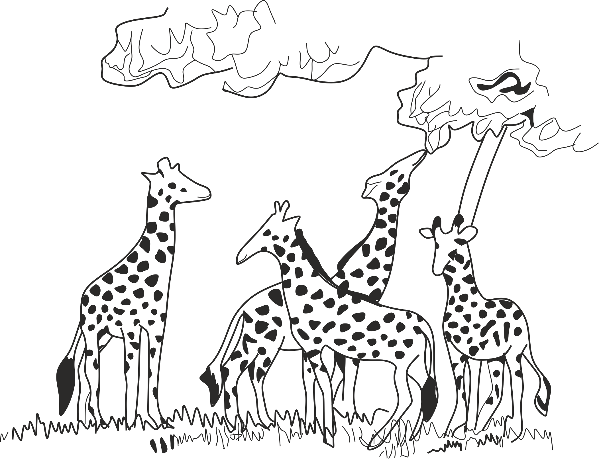

**Fig 5.6 a**

The ancestor giraffes probably had necks that varied in length

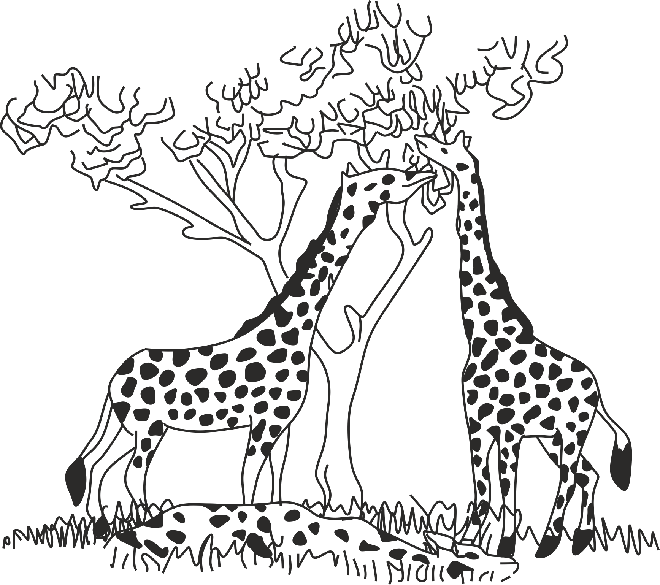

**Fig 5.6b**

Competition and thus natural selection lead to the survival of long necked giraffes and elimination of short necked giraffes

**Fig 5.6** development of long neck of giraffes by Darwin

**SAQ 5.8**

**TAHOSSA 2014**

* How could Darwin with his theory of natural selection explain the development of webbed feet in ducks

**Strength of Darwin theory**

* The theory explains evolution more scientifically than Lamarck theory, i.e., in terms of variation.
* The theory puts more emphasis on the role of environment in evolution.
* The theory explains clearly the concept of the struggle for existence among organisms for the limited resources such as food, and water.
* The theory explains the origin of species by natural selection, this idea stops the debate on the special creation theory which believed that species once created remained fixed.
* The theory explains clearly that only the adapted individuals develop to maturity and reproduce for the next generation.

**Weaknesses of Darwin theory**

* The theory did not explain the causes of variation such as mutation and genetic recombination.
* The theory did not explain how variations are passed from parents to offspring.
* The theory did not explain clearly how fit traits are naturally created and maintained, although the theory explain the survival of the fittest and elimination of unfit.
* The theory did not explain how life on the earth originated, instead, it focuses on how species might arise from the pre-existing species.
* The theory did not explain the inheritance of vestigial organs which are persisting from generation to generation without elimination.
* The theory did not explain the inheritance of over specialised organs like tusks of elephants which have developed beyond the stage for maximum usefulness.
* The theory excludes the ecological roles of the less adapted organisms that reach the reproductive age.

**SAQ 5.9**

**BAOBAO WEEKELY TEST 2010**

* Explain the Darwin theory of natural selection and citing the strengths and weaknesses

***Neo – Darwinism theory (mutation theory)***

Neo Darwinism is the theory of organic evolution by natural selection based on the Mendelian genetics. It was proposed by Hugo de Vries, a Dutch scientist in 1809. According to this theory, the origin of species by natural selection is brought about by changes in the gene frequency or genotypes in large populations. This theory states that “*the fundamental origin of genetic variations or change in gene frequency in a population are mutation, random assortment of chromosome, genetic recombination and genetic drifting (elimination of gene from a population)*., as the result, some of the genotypes tend to be naturally selected and others are eliminated, the selected one tend to reproduce giving rise to new offspring.

**Strength of Neo Darwinism theory**

* The theory explains organic evolution more scientifically, that is; in terms of genetics.
* The theory demonstrate evolution in progress, especially at the micro level.

**Weaknesses of Neo Darwinism theory**

* The theory did not explain the origin of species or organisms of distinctive forms of behaviour.
* The theory explains adaptation or micro – evolution as a means of species creation, For example, the theory assumes that there is random genetic variation followed by selection.

**SAQ 5.10**

**TAI QUESTION**

* Show how the modern view of natural selection modifies the theory put forward by Charles Darwin.

**5.4 EVIDENCES OF ORGANIC EVOLUTION**

Scientist can prove that evolution has taken place by various evidences. The following are the main evidences supporting the theory of evolution:

* *Palaeontology*
* *Comparative anatomy*
* *Comparative embryology*
* *Comparative biochemistry*
* *Taxonomy*
* *Biogeography*
* *Artificial selection*

***Palaeontology***

**Palaeontology** is the study of the remains of past life called fossils; when plants and animals die, their remains are either decomposed by bacteria or preserved as fossils. *Fossils* are therefore defined as remains, traces or imprint of life that have been preserved at some time in the geological past. They prove that varieties of animals and plants existed in various geological ages of the earth.

**Fossil formation**

The process of fossil formation is known as **fossilization** (Fig 5.7). However, not all organisms that die become fossils. This is because most of them rapidly decompose after death. The most common method of fossilization involves the ultimate conversion of the hard parts of the body such as shells, bones and teeth in animals or woody parts in plants into rock.

* Dead organisms such as plants or animals are buried in the soil pool and decompose.
* Hard parts of skeleton of plants and animals become impregnated by slow setting down of mineral enriched sand (silica or carbonate ions) caused by flooding, heavy rain , wind blown or volcanic ash and preserved as sedimentary rock.
* The compressed layers of sedimentary rock called stratum are formed. The lowest stratum which are deposited first, contains the fossils of the primitive forms of life, whereas the upper stratum contain fossils of more complex and advanced plants and animals.
* After millions of years, upthrust may bring rocks to the surface and erosion of these rocks may expose some fossils

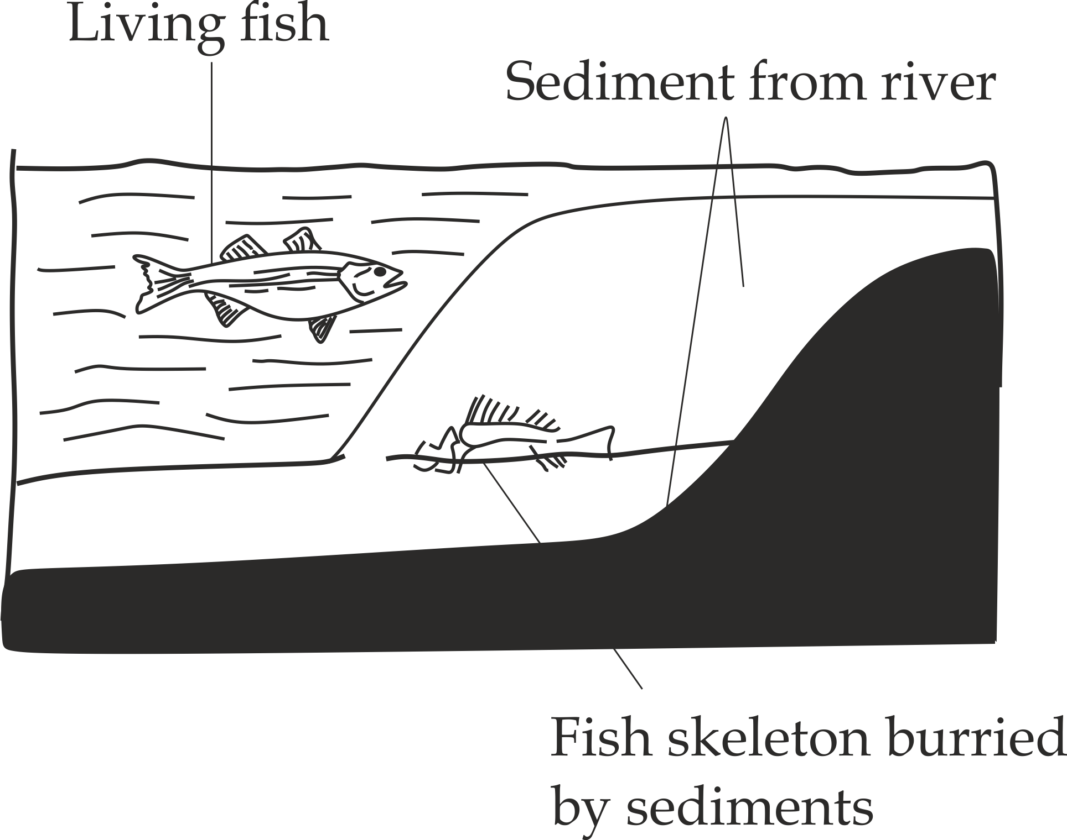

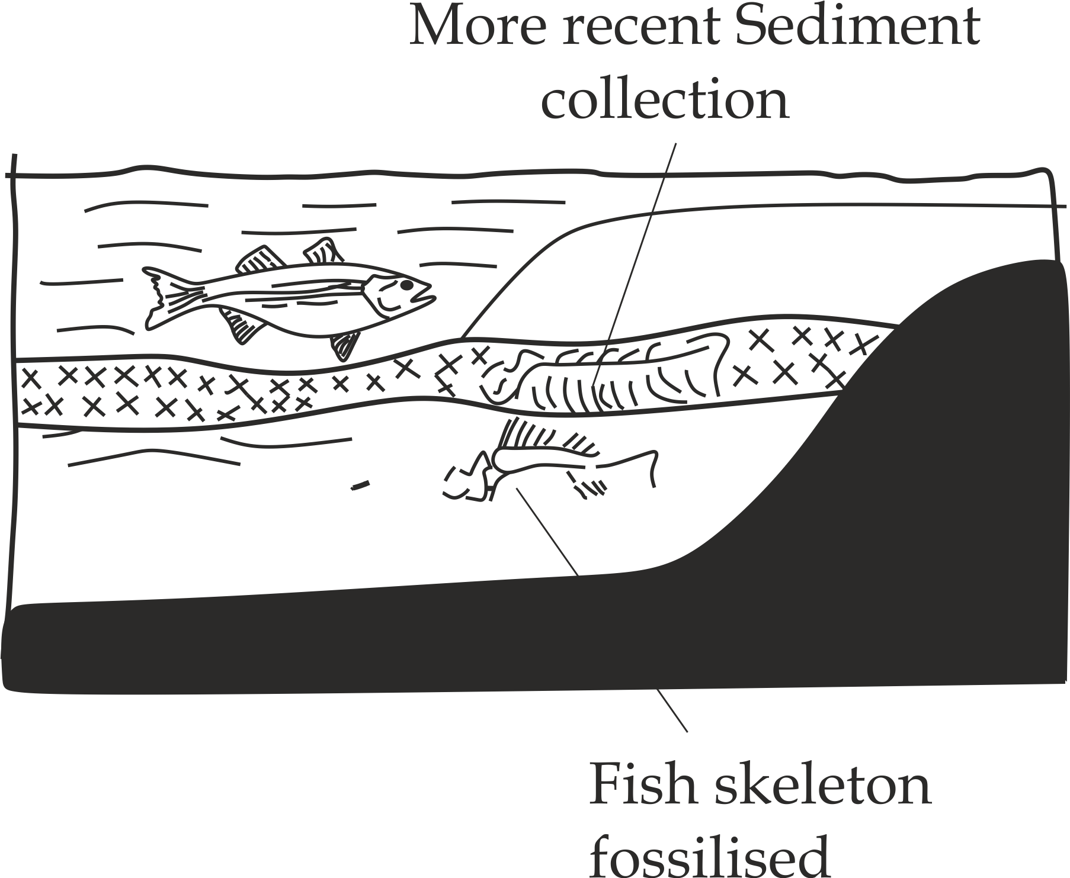

A

B

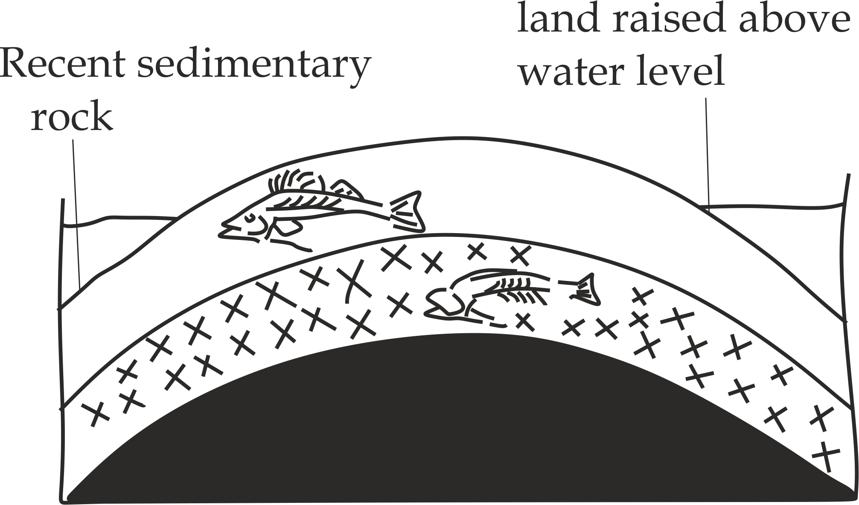

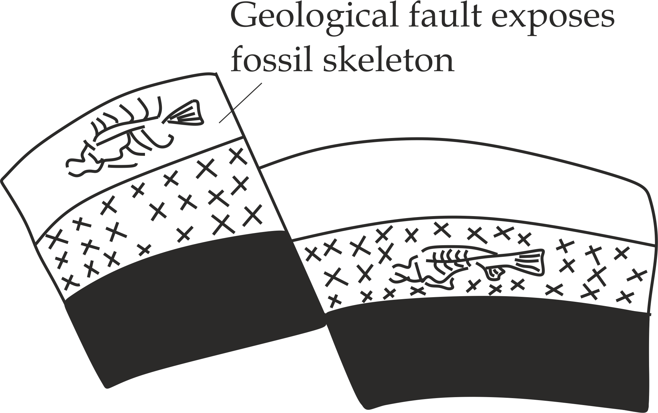

C D

**Fig 5.7** Formation of fossils

**SAQ 5.11**

**NECTA 1999**

* What is a fossil? Very briefly describe how fossils are formed?

**Types of fossils**

Depending upon what parts of the organisms are preserved, there are seven types of fossils include - **entire organism**, **hard skeletal material**, **petrified**, **moulds**, **compressed, imprints** and **coprolites**

1. **Entire organism**

In this type of fossils, the entire body of organism is preserved. The preserved materials can be ice, tar, amber or oil seeps. Example of this include woolly mammoth found in Siberia (Fig 5.8).

1. **Hard skeletal materials**

These fossils are formed when hard skeletal parts such as teeth, bones skull and shells are trapped by sedimentary sands and clay which in turn form sedimentary rocks.

1. **Petrified fossils**

This kind of fossil is formed when minerals such as silica, pyrites and calcium gradually replace the organic material in a body of buried organism and eventually fill the space left as the organism decays. Example, silica replace the echinoderm.

1. **Moulds or casts**

Organisms buried in sediments slowly decompose and dissolve away leaving a cavity or mould that contains an exact imprint of the organisms shape and size. i.e., cast of footprint (Fig 5.9).

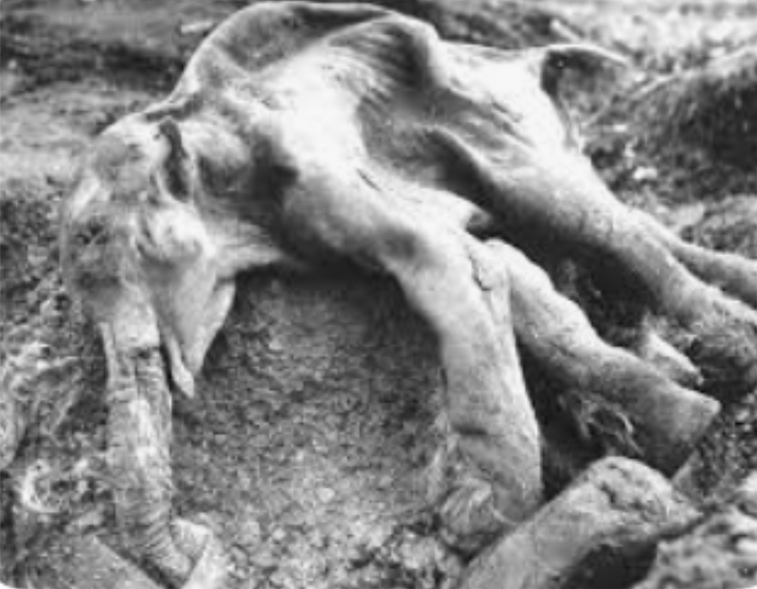**Fig 5.8** mammoth found in Siberia (10, 000 years old)

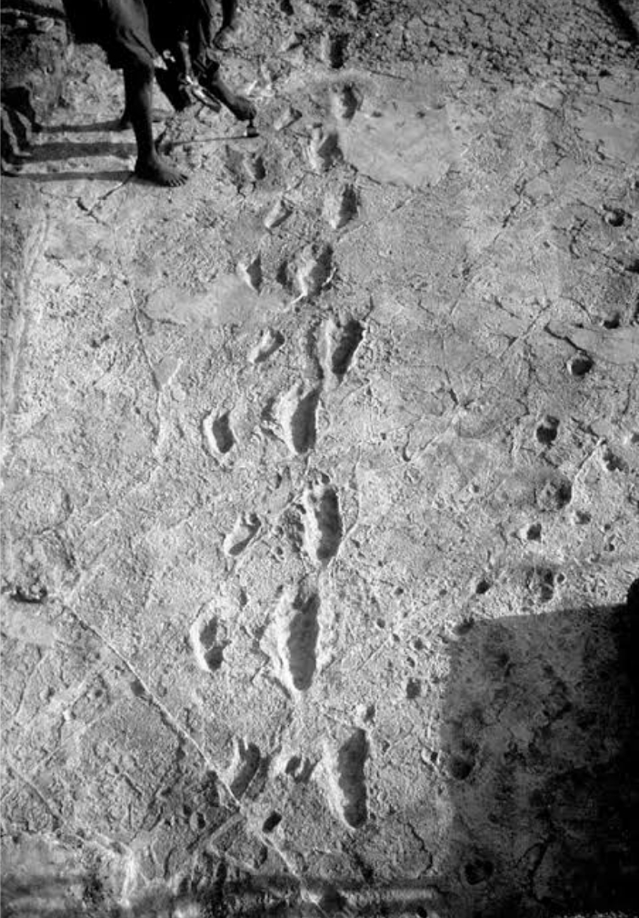

**Fig 5.9** The cast of footprint in Laetoli site near Olduvai Gorge in Tanzania which was discovered by Dr. Mary Leakey in 1976.

1. **Imprints**

These are fossils in the form of footprints, trails, tracks and tunnels of diffent organisms, for example footprints of dinosaurs.

1. **Compressed or carbonized plant fossils**

These are fossils which are formed when the oils in the plant cells are leached out and the remaining matter is reduced to carbon film. The plants are often fossilized through carbonization such as a coal.

1. **Coprolites**

These are formed pellets that are prevented from decomposing and later get compressed in sedimentary rocks. They often contain some evidences of the food eaten. The example for this is Cenozoic mammalian faecal remains.

**SAQ 5.12**

**MTWARA AND LINDI MOCK – 2022**

* Briefly explain types of fossils that support organic evolution

**Fossils as evidence of organic evolution**

There are two (2) main reasons which support the fossil studies as the evidence of organic evolution among living organisms of the given species.

Firstly; the fossil record suggest that; the complex and advanced forms of plants and animals evolved from simple and primitive forms of life. For example, research on fossils has shown that the earliest fossils were monera, followed by protoctista and then fungi. The oldest fossils of animals are those of fishes followed by amphibians and latest are mammals.

Secondly; The fossil record suggest that, The structure of organisms do not remain fixed but rather change from simple to more complex forms. The fossils of the single organisms are formed in the deeper layer of the sedimentary rocks are simple and those of the more complex are found in the upper layer. This indicates evolutionary relationship among organisms. For example, the study of fossils of horses revealed the evolutionary trend among horses through various generations in the environment. According to the history of the horse from fossil records found in the North American sedimentary rocks is used as one of the best examples of evolutionary changes, the development of a horse was gradual, fossils indicate that 60 million years ago horses were not bigger as a modern day horse. They were simple, primitive with four toes *Hyracotherium*, it has taken million years for the ancestral horse to change into the horse of today which are more complex, advanced with two toes *Equus*.As shown in Fig 5. 10, changes in the structure of the horse’s body enabled it to cope with the changing environment around it through the process of adaptation.

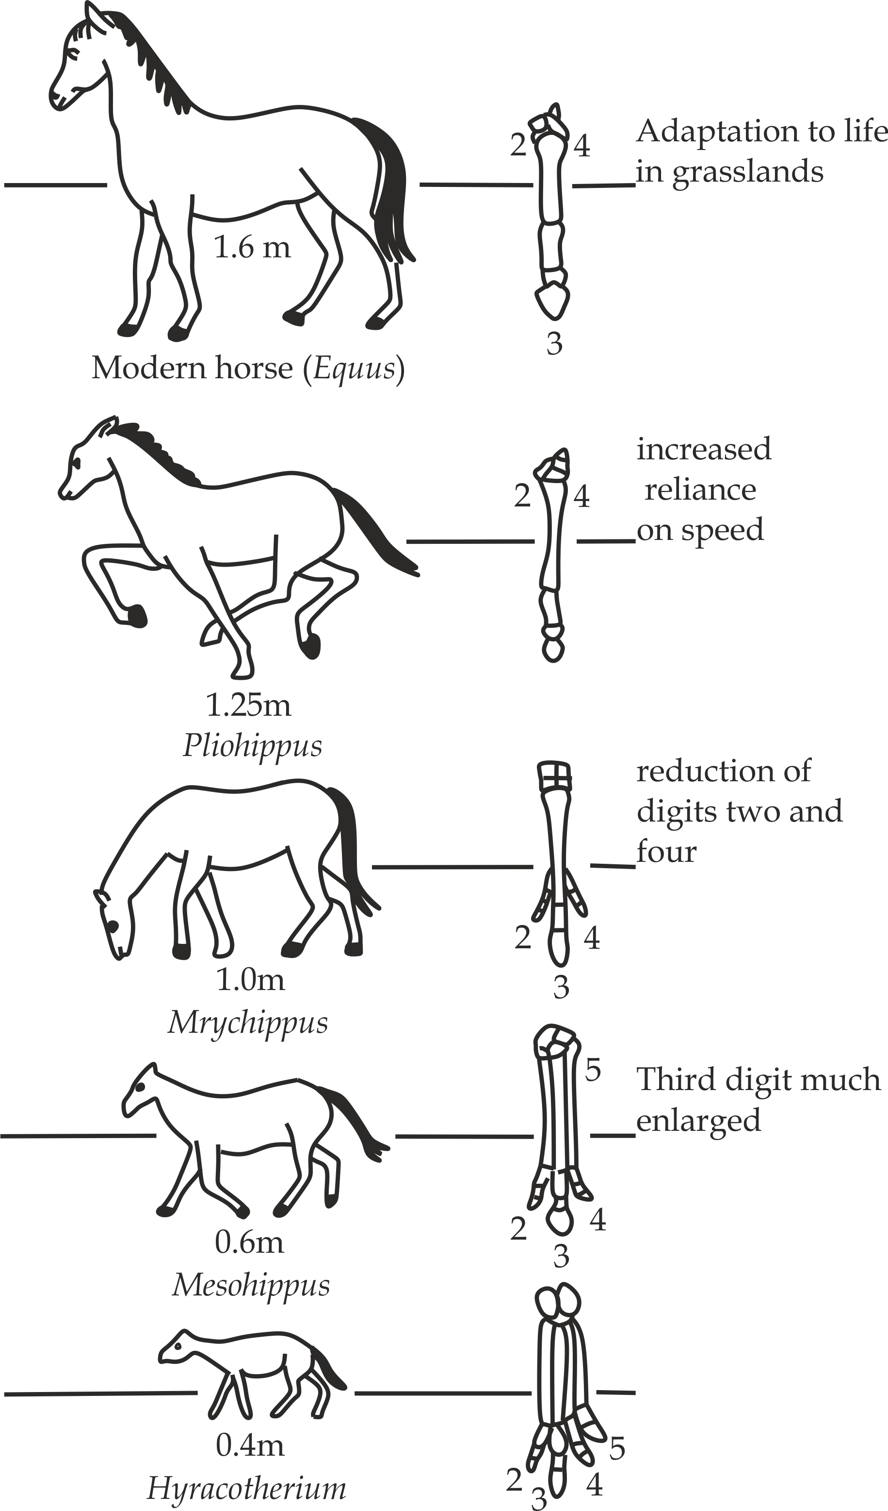

**Fig 5.10** Evolution of horse from simple primitive form to complex form

**Weaknesses of fossil evidences**

Fossils evidences is insufficient to prove that evolution has occurred but it only show progressive increase in complexity of organisms. One major criticism of using fossil evidence in support of evolutionary theory is the lack of continuous records in tracing the fossil records and termed as “ *missing* *links*“ . There are various reasons for the incompleteness of fossil records or missing links which may be explained in terms of the following challenges or limitation of fossil records: Firstly, Dead organisms decompose rapidly. Secondly, Soft organisms do not fossilised easily. Thirdly, only small fraction of fossils have been discovered. Fourthly, Dead organisms are eaten by scavengers. Fifthly, the fossils can be destroyed by geological activities such as earth quakes and erosion. Lastly, Most fossils convey information about external forms, but little about how the organism function, change in the cause of time from simple to complex.

**SAQ 5.13**

**DAR MOCK 2021**

* What are the problems associated with fossil records as evidence that support organic evolution.

***Comparative anatomy***

**Comparative anatomy** is the study which compares body structures or parts of different organisms. Comparative study of the structures among different organisms reveals fundamental similar pattern of structure which indicate evolutionary relationship. This is explained based on three categories of structures which support the evidence of organic evolution – **homologous**, **analogous** and **vestigial structures**.

1. **Homologous structures**

These are organs or body parts of different organisms having the same basic structures but perform different roles. For example, limbs in all vertebrates have the same basic structure called **pentadactyl limbs**, that is; limbs with five digits, however, due to adaptive radiation, similar parts are adapted to perform different roles, For example, wings in bat for flying, flippers in whale for swimming, forelimbs in monkey for grasping, forelimbs in horses for running and forelimbs in monkey for grasping, forelimbs in pig for walking and mole for digging Fig 5.11 shows the adaptive radiation of pentadactyl limb in vertebrates. Another example is **Darwin finches** (small black birds in Galapagos Islands) have the same basic structure but perform different roles depending on the mode of feeding such as insectivorous finches for feeding insects, vegetarian finches for feeding bud and fruits, cactus finches for feeding cactus plants, ground finches for crushing seeds.

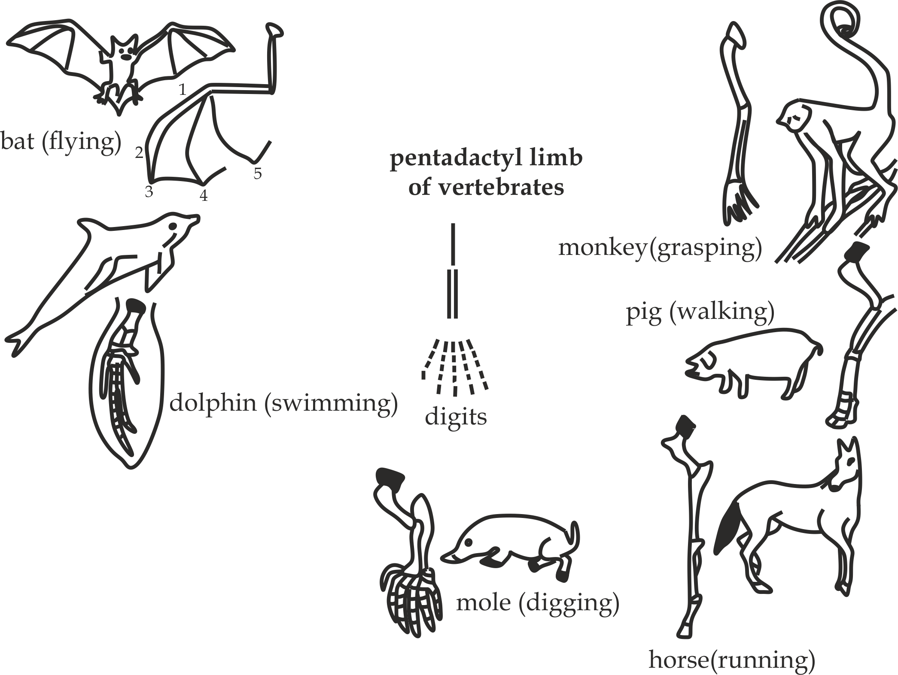

**Fig 5.11** pentadactyl limbs in some vertebrates

**Homologous structure as evidence of divergent evolution**

**Homologous structures** suggest that the same basic structures show that different organisms originated from the common ancestors, the difference in function is due to adaptation to different habitats. This pattern is called **divergent evolution**.

**Key pointstudy tip**

* **Homologous structures** are organs from different organisms having the same basis structures but perform different roles.Example, pentadactyl limbs in vertebrates.
* **Divergent evolution** is a type of evolution whereby living organisms originated from the common ancestral origin but perform different functions.

1. **Analogous structures**

**Analogous structures** are organs of different organisms having different basic structures but perform similar role.For example, wings of insects and birds (Fig 5.12) all are used for flight but they have different structural organization in which insects wings are membranous whereby birds wings are cartilagenous.

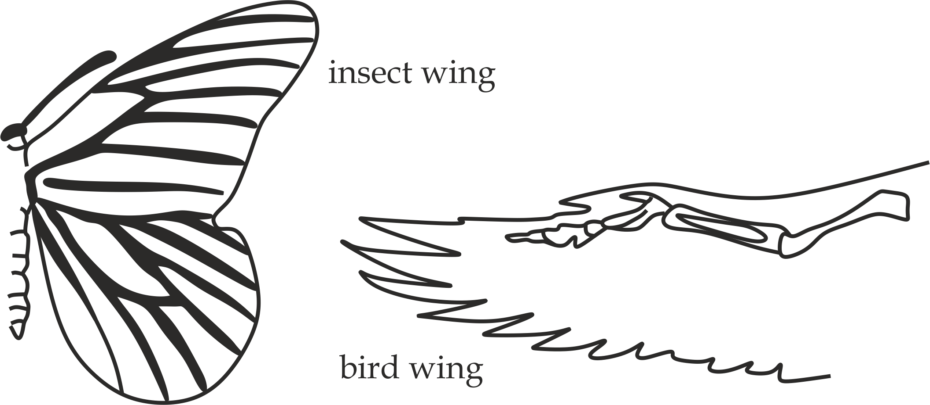

**Fig 5.12** Analogous structures

**Analogous dstructures as evidence of convergent evolution**

**Analogous structures** suggest that, since different organisms perform the same role although are not originated from the common ancestor, but they can still evolve to have similar basic structure. This patern is called **convergent evolution**.

**Key points**

* **Analogous structure** are organs from different organisms having different structures but perfom the same role. Example; wings of insects and birds.
* **Convergent evolution** is a type of evolution whereby living organisms originated from different ancestral origin but perform the same role.

1. **Vestigial structures**

**Vestigial structures** are organs that are reduced and ceased to be functional in the course of time. Such organs were typically functional in the ancestral species but are now non functional or have changed functions; Example; the appendix , coccyx, nictating membrane in man,

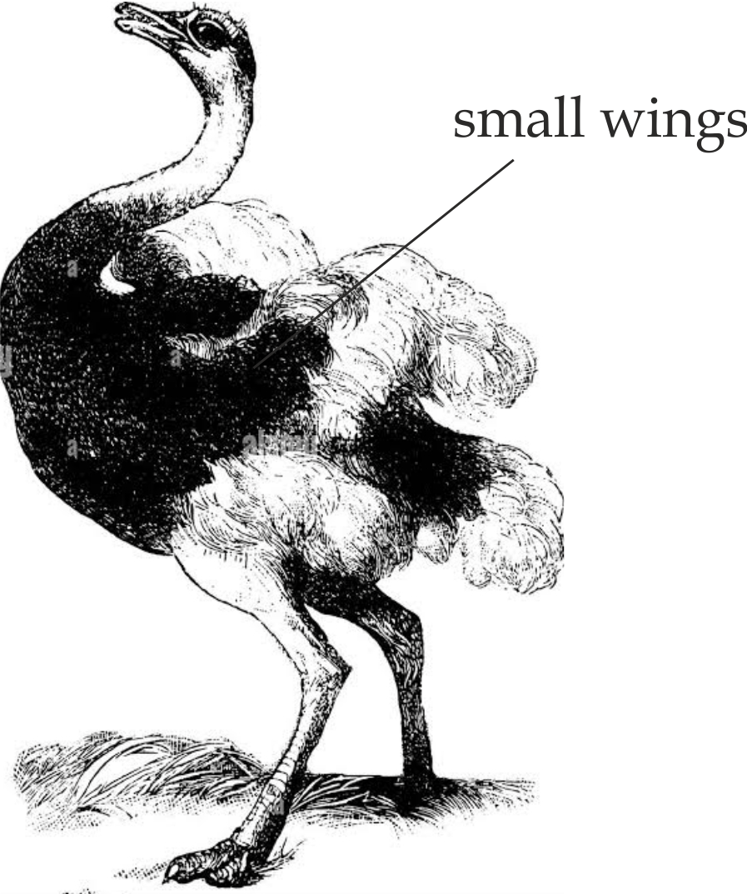

**Fig 5.13** the small wings of ostriches are not used for flight. They are vestigial structures.

Wings of flightless birds such as ostrich (Fig 5.3), kiwi and emu are reduced and hence not used for flight, hind limbs in python snakes and whale are reduced and remain as a rudimentary pelvic girdle.





There are about 80 total number of the vestigial organs in the human body.

**Vestigial structures as evidence of evolution**

**Vestigial structures** suggest that, the presence of vestigial organs among different organisms indicate that; they are originated from the common ancestral form, however as a result of evolution, such structures have been reduced to become non-functional.

**Key point**

* **Vestigial structure** are organs that are reduced and ceased to be functional in the course of time. Example appendix and coccyx in man.

**SAQ 5.14**

**KILIMANJARO MOCK 2018**

* What do you understand by the term organic evolution?
* Using relevant examples, explain how comparative anomy support the theory of organic evolution.

***Comparative anatomy***

**Comparative anatomy** is the study that compares and contrasts embryos of different organisms in vertebrates to show how animals and plants are related. This study of embryonic development among vertebrates is called **embryology**.

**Comparative embryology as evidence of evolution**

The similarity in structures of embryo from different vertebrates show the evolutionally relationship from common ancestral origin. For example, all vertebrate embryo Fig 5.14 have visceral cleft in the pharyngeal region, post anal tail and a series of internal paired gill pouches.

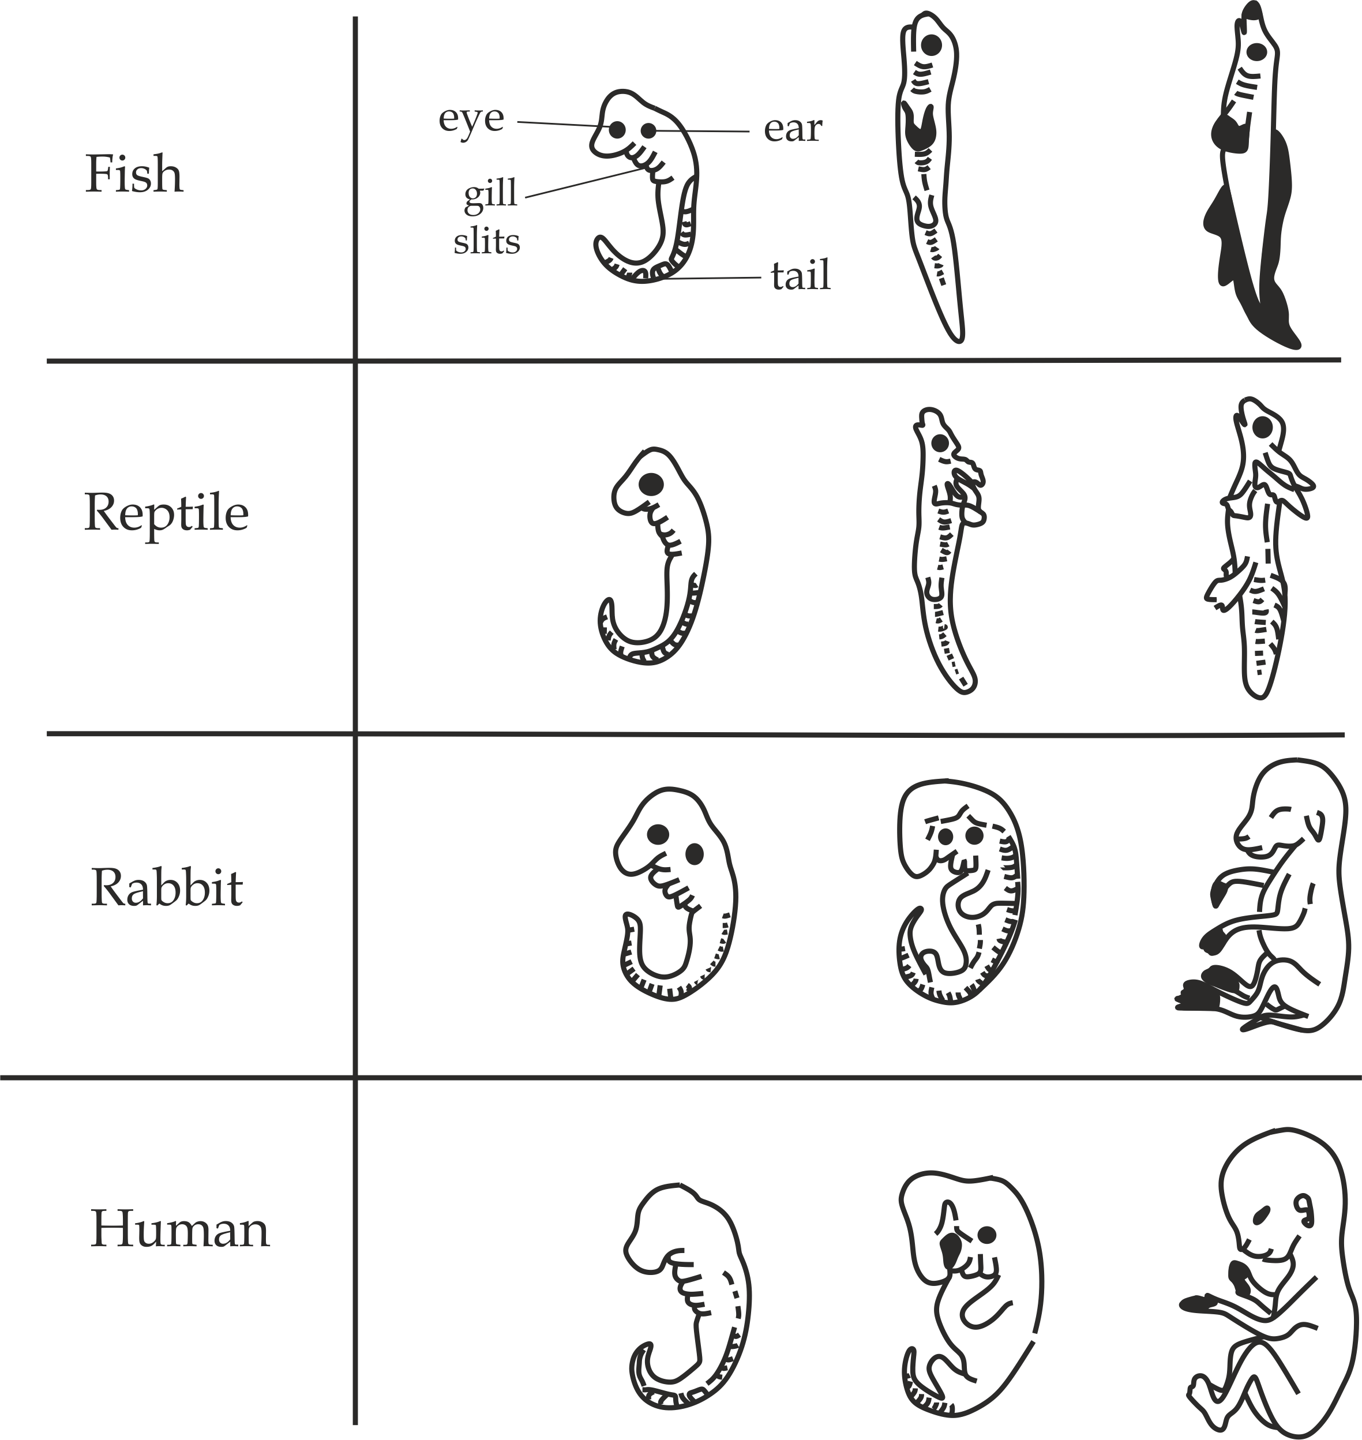

**Fig 5.14** Embryonic comparison in four vertebrates, similarities indicate a common evolutionary origin

***Comparative biochemistry***

**Comparative biochemistry** is the study that compare chemical components of the cell and physiological processes of different organisms.

**Comparative biochemistry as the evidence of evolution**

The evidence of comparative biochemistry is derived from the following sources – **basic cellular components** and **basic physiology**.

1. **Basic cellular components**

The occurrence of similar chemical composition of the cells in a complete range of living organisms, suggest the evolutionary relationship among organisms from common ancestral origin. For example; DNA and ATP are the same in many organisms, chlorophyll is the same in all photosynthetic plants and haemoglobins are the same in all animals.

1. **Basic physiology**

The occurrence of similar physiological processes in a complete range of organisms, suggest the evolutionary relationship among organisms from the common ancestral origin. For example; hormones in chordate have similar roles.eg, Insulin extracted from cattle and pigs is chemically and structurally similar to human insulin, therefore, it is used to treat diabetes, similar enzymes of different animals in their chemical nature and mode of action.eg, amylase hydrolyses starch into maltose in man, protozoans, amphibians, reptiles; also components of blood and lymph and their functions are similar in different organisms, eg, man, chimpanzee and gorilla share common blood proteins

**SAQ 5.14**

**JECAS 2006**

* Outline how the chemical composition of organisms can reveal that all living things arose from a common ancestral group.

***Taxonomy***

**Taxonomy** is a branch of classification which that is based on comparing the similarities and differences between organisms across the groups called taxa.

**Taxonomy as evidence of organic evolution**

**Taxonomy** suggest that; the similarities in structures and characteristics from different organisms show the evolutionary relationship from common ancestral origin. The difference may be explained as due to adaptation of organisms in changing in environmental condition within each taxa over period of time. This evidence is also describes as the **linear classification**.

**SAQ 5.15**

**JOINT DAR 2021**

* Briefly explain how taxonomy, physiology and biogeography support the idea of organic evolution.

***Biogeography***

**Biogeography** is the study of the distribution of animals (fauna) and plants (flora) in different parts of the world.

**Biogeography as the evidence of organic evolution**

The evidence from biogeography is derived from the following sources – **continental drift** and **oceanic island distribution of organisms**.

**Biogeography as evidence of organic evolution**

The presence of different plants and animals in the areas that were once adjacent in the past indicates that; organisms were originated from the common ancestral, however the geological isolation cause the organisms to adapt different by the pressure of natural selection in order to cope with new environmental conditions. This pattern of adaptation is called **adaptive** **radiation**, which is an example of divergent evolution. Example of adaptive radiation which support the biogeography as evidence of organic evolution include - **Darwin finches** and **continental drift.**

1. **Darwin finches**

**Darwin finches** are small sized black birds found in 20 – different islands of Galapagos. Darwin suggests the, the ancestral species was seed – eating ground finches Fig 5.15 which living in South America mainland, the oceanic volcanic activity push and separate the mainland into 20 different islands of Galapagos, the finches also became geographical isolated for a long period, they adapted differently in their feeding habits so developing different types of beaks as the result new kind of finches evolve from a common ancestor.

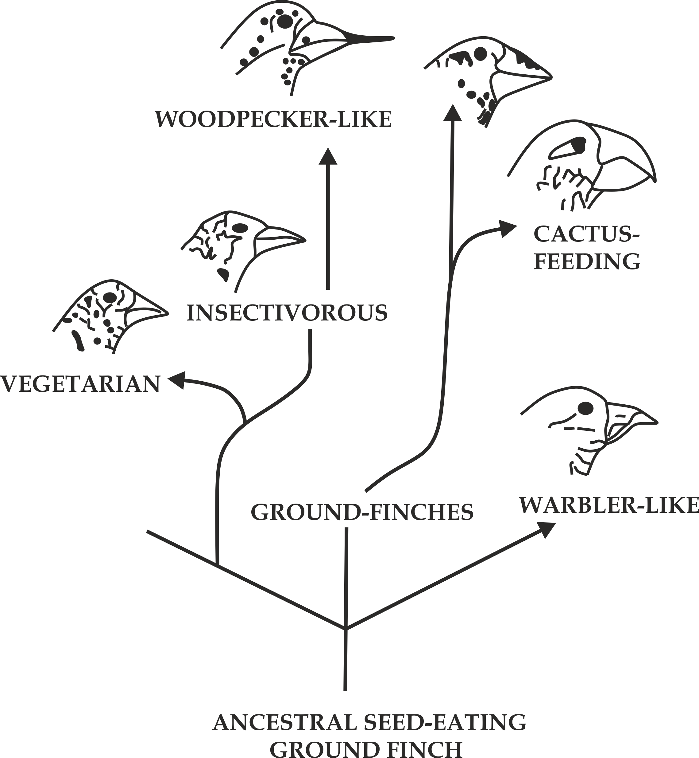

**Fig 5.15** Darwin finches

1. **Continental drift**

Geological evidence suggest that, About 200 million years ago, all landmasses of the continents of earth constituted one large supercontinental called **pangea**, after continental drift Fig 5.16 different kind of species are found in the areas that were once adjacent in the past, this indicates the evolutionary relationship among organisms. For example; south America, Africa and Australia were connected together in the southern hemisphere as **gondwana**, However; Llama, pumas (a mountain lion) and Jaguar are found in south America only; monkey, apes, lions and antelopes are found in Africa only while marsupials animals such as kangaroo in Australia only.

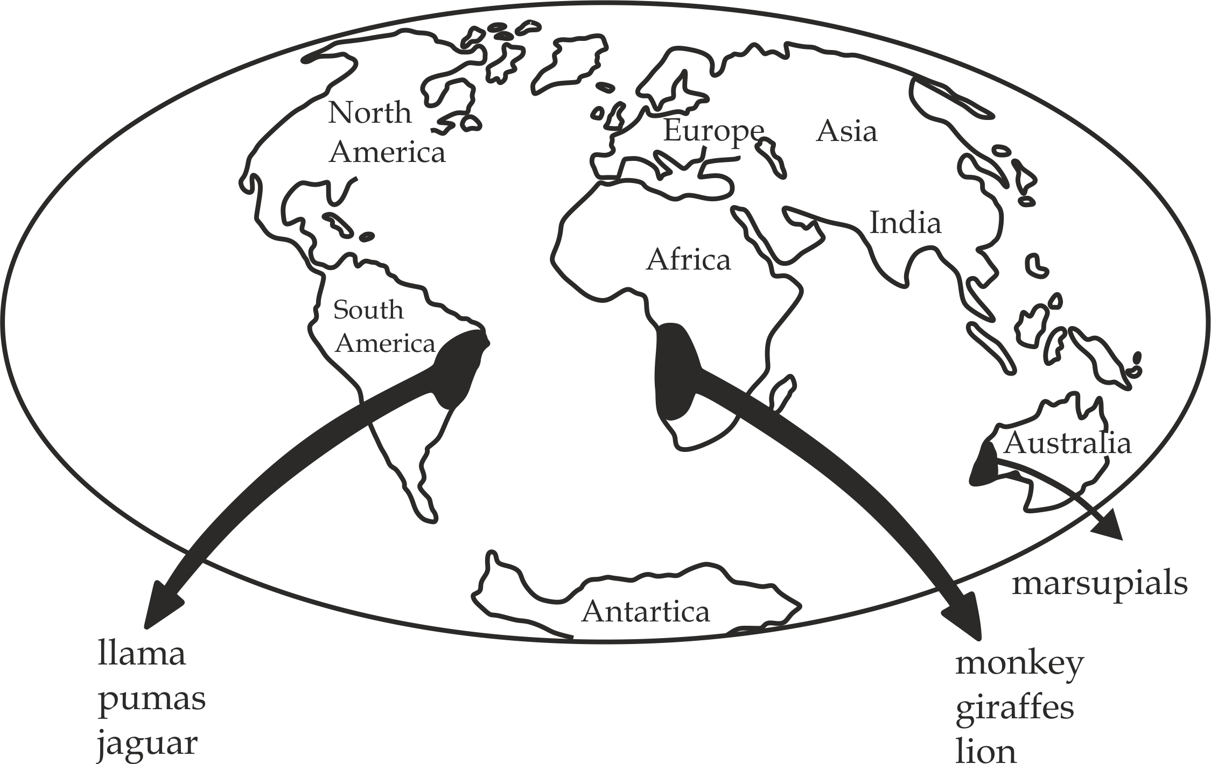

**Fig 5.16** continental drift as the evidence of organic evolution

***Artificial selection***

**Artificial selection or selective breeding** is the process in which human choose to breed two individuals of plants and animals each with desirable traits to obtain one organism with a combination of both desirable traits. For example, emergence of high yield crops in plants or high yield milk and meat in animals.

**Artificial selection as evidence of organic evolution**

Artificial selection suggest that, continuous selective breeding on plants and animals by human has produced varieties that gave rise to the new species of animals and plants, since new characteristics can be produced by human ability through selective breeding, then this is the evidence for mechanism by which species must have arose naturally and so support the theory of evolution.

**SAQ 5.16**

**MOCK WESTERN ZONE 2019**

* Explain how the following support the theory of organic evolution

1. Comparative anatomy
2. Palaeontology
3. Taxonomy
4. Geographical isolation
5. Plant and animal breeding

**5.5 THE CONCEPT OF SPECIATION**

**Speciation** refers to the origin of new species from the pre-existing ones in the course of evolution. Speciation, therefore, is the changing of individuals within a population such that they are no longer part of the same species. Speciation is divided into three (3) main types namely- **allopatric**, **sympatric** and **parapatric speciation** Fig 5.17.

***Allopatric speciation***

**Allopatric** is a type of speciation which occurs as a result of two populations becoming geographically isolated by the physical barrier such as a mountain range, river or desert. The allopatric (= ‘*different countries’*). A famous example of allopatric speciation is the use of Darwinism finches of the Galapagos Islands, which are considered to have been specialized allopatrically because of volcanic eruption that divided the population.

***Sympatric speciation***

**Sympatric** is a type of speciation which occurs as a result of two populations in the same geographical area but different ecological niche becoming reproductive isolated. The symplastic (= ‘same *countries’*).

***Parapatric speciation***

**Parapatric** is a type of speciation which occurs as a result of smaller population is isolated partially at the peripheral of a large population by the physical barrier to the extent of becoming a new species (=*‘near country’*).This type of speciation is not very common in populations.

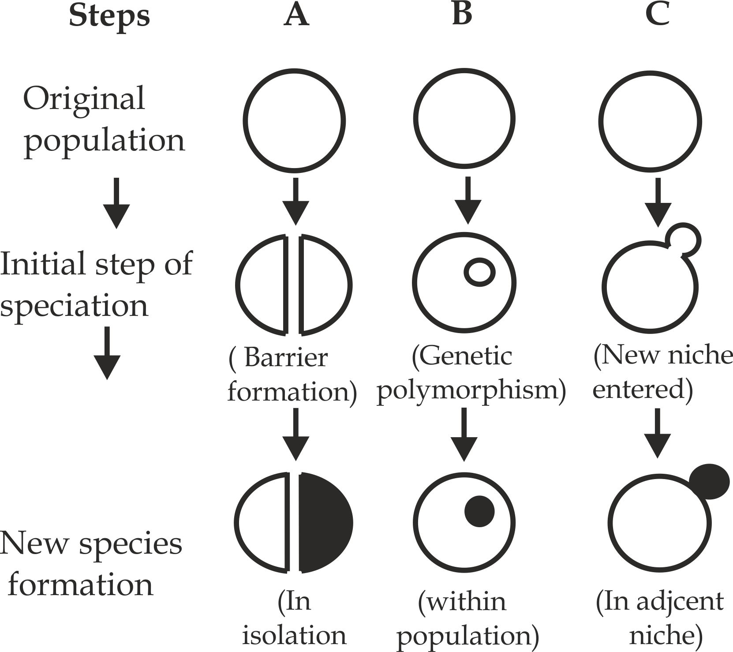

**Fig 1.17**

Types of speciation

**A** – Allopatric

**B** - Sympatric

**C** - Parapatric

**SAQ 5.17**

**JECAS 2016**

* What is meant by speciation
* Describe the various types of speciation.

***Mechanism of speciation***

The mechanism which operates to bring about speciation includes

* *Mutation*
* *genetic recombination*
* *geographical isolation*
* *reproductive isolation*
* *artificial selection*
* *Natural selection*.

***Mutation***

**Mutation** is a sudden and permanent change in the genetic constitution of an organism .If a mutation is beneficial and involve the reproductive cells (gametes), it can make the organism bearing it (mutant) to survive best in a given environment and pass on the mutation to the next generation, finally new species is evolved. For example, the existence of antibiotic resistant bacteria in hospital environment, the antibiotics are toxic drugs that kill bacteria over a period of time. If at the end of that period of time not all bacteria are killed. The survival bacteria undergo mutation and become resistance to antibiotics whereby these bacteria pass the mutation to the next generation as the result the new species is evolved.

**SAQ 5.18**

**DAR MOCK 2017**

* Explain the existence of antibiotic resistant bacteria in hospital environments though patient carrying bacteria are treated with antibiotics.

***Genetic recombination***

In genetic recombination traits from different organisms are combined naturally to give one trait, genetic recombination includes independent assortment of genes, random fertilization and crossing over during meiosis, organisms formed from the genetic recombination are naturally selected to survive best in a given environment and pass their traits to the next generation as the result new species is evolved.

***Geographical isolation***

This type of speciation occurs as a result of two populations becoming geographically isolated by the physical barrier such as river, mountain and flooding. Geographical isolation is the most common way in which new species are formed. The geographical barrier creates spatial separation that prevents mating and gene flow between members of two separated population. The prolonged separation may result into adaptation to new environment by natural selection which change the gene pools of each group, in this way new species may arise; Example frogs are geographical isolated from one another by the area of deforestation in amazon basin.

***Reproductive isolation***

This type of speciation occurs as a result of the two populations in the same geographical area becoming reproductive isolated. The isolating mechanism in reproductive isolation can be splitted into two categories – **prezygotic** and **postzygotic** **mechanism**.

1. **Prezygotic mechanism**

These are isolating mechanisms that interfere with the reproduction process before fertilization process has taken place.i.e. Before zygote formation. They include the following:

1. **Ecological isolation or habitat isolation**

The species become reproductive isolated because they live in different habitats in the same geographical area, In this case, species do not meet because they are in different habitat preference; For example, ecological isolation will certainly affect many parasite populations.

**Fig 5.18** great crested grebs show the courtship behaviour

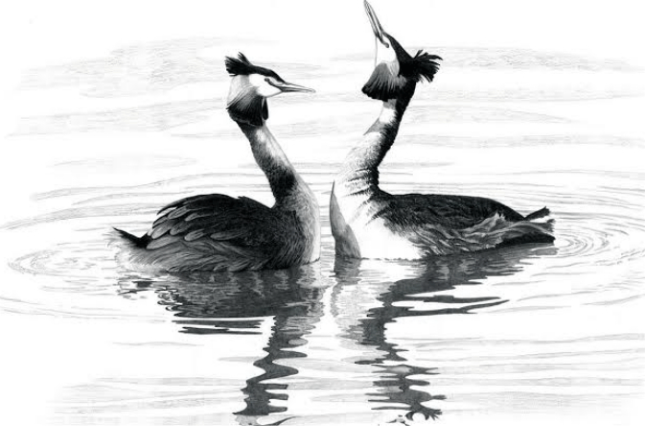

1. **Behavioural isolation**

The species become reproductive isolated due to difference in their courtship behaviour such as sexual songs of birds or calls of frogs must be exact if they are to elicit the appropriate breeding response from the opposite sex.For example, Fig 5.18 the great crested grebs have an impressive courtship behaviour, they both shake their heads from side to side with wings lift.

.

1. **Temporal isolation**

The species become reproductive isolated because they reproduce in different times of the day or years, example, animals with oestrous in different seasons.

1. **Mechanical isolation**

The species become reproductive isolated due to different in the reproductive structures. Example, in mammal, if male penis does not enter the female vagina.

1. **Post zygotic mechanism**

These are isolating mechanisms that interfere with reproduction process after fertilization has taken place, they include the following:

1. **Hybrid inviability**

This happens whereby are produced but fail to survive to maturity.

1. **Hybrid sterility**

This happens whereby hybrid fails to produce functional gametes. For example, a cross between a horse (2n = 60) and a donkey (2n = 66) produce a mule (2n = 63) which is sterile. A mule cannot produce a mule.

**SAQ 5.19**

**DAR MOCK 2018**

* Explain the causes of reproductive isolation between organisms of the same species in particular geographical area.

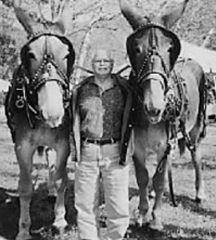

**Fig 5.19** Two famous mules in Columbia produced from breeding donkey and horse.

***Artificial selection***

**Artificial selection** is the process through which two individuals each with a set of desirable characteristics are bred so as to obtain an organism with both sets of desirable characteristics. It involves selective breeding to produce desirable characteristics in offspring as the result species is evolved. By selective breeding man has been able to develop different new types of domestic animals and new varieties of plants which are so much different from the wild (common) forms that they can be classified almost as separate species. Examples of artificial selection in plants and animals include:

* Firstly, emergy of new strains of plants and animals which reproduce rapidly such as maize or bean with high yield crops/fruits and cow with high yield milk.
* Secondly, emergy of diseases – resistant strains of plants and animals such as plant resistant to DDT.
* Thirdly**,** emergy of large size animals and plant products such maize with big seeds or cow with large amount of meat.
* Fourthly**,** emergy of new species such as new breeds of donkey and horse to produce a mule Fig 5.18.
* Lastly, emergy of new method of fertilization.eg, the Artificial insemination mechanism.

***Natural selection***

It is the mechanism by which the nature (environment) itself select the organisms that are well adapted to survive. Thus favoured or selected organisms will now reproduce comfortably and pass their traits to the next generation as the result new species is evolved by natural selection.

**Types of natural selection**

There are **three (3)** types of natural selection, namely: directional, stabilizing and disruptive selection.

1. **Directional selection**

It is a type of natural selection in which the nature select one extremity trait, i.e., more adapted individuals are favoured. This produces more and more adapted individuals in the population when such a selection operates for many generation. In this type of selection, more individuals acquire value other than mean character value. So the peak of graph shift in one direction Fig 5.20.

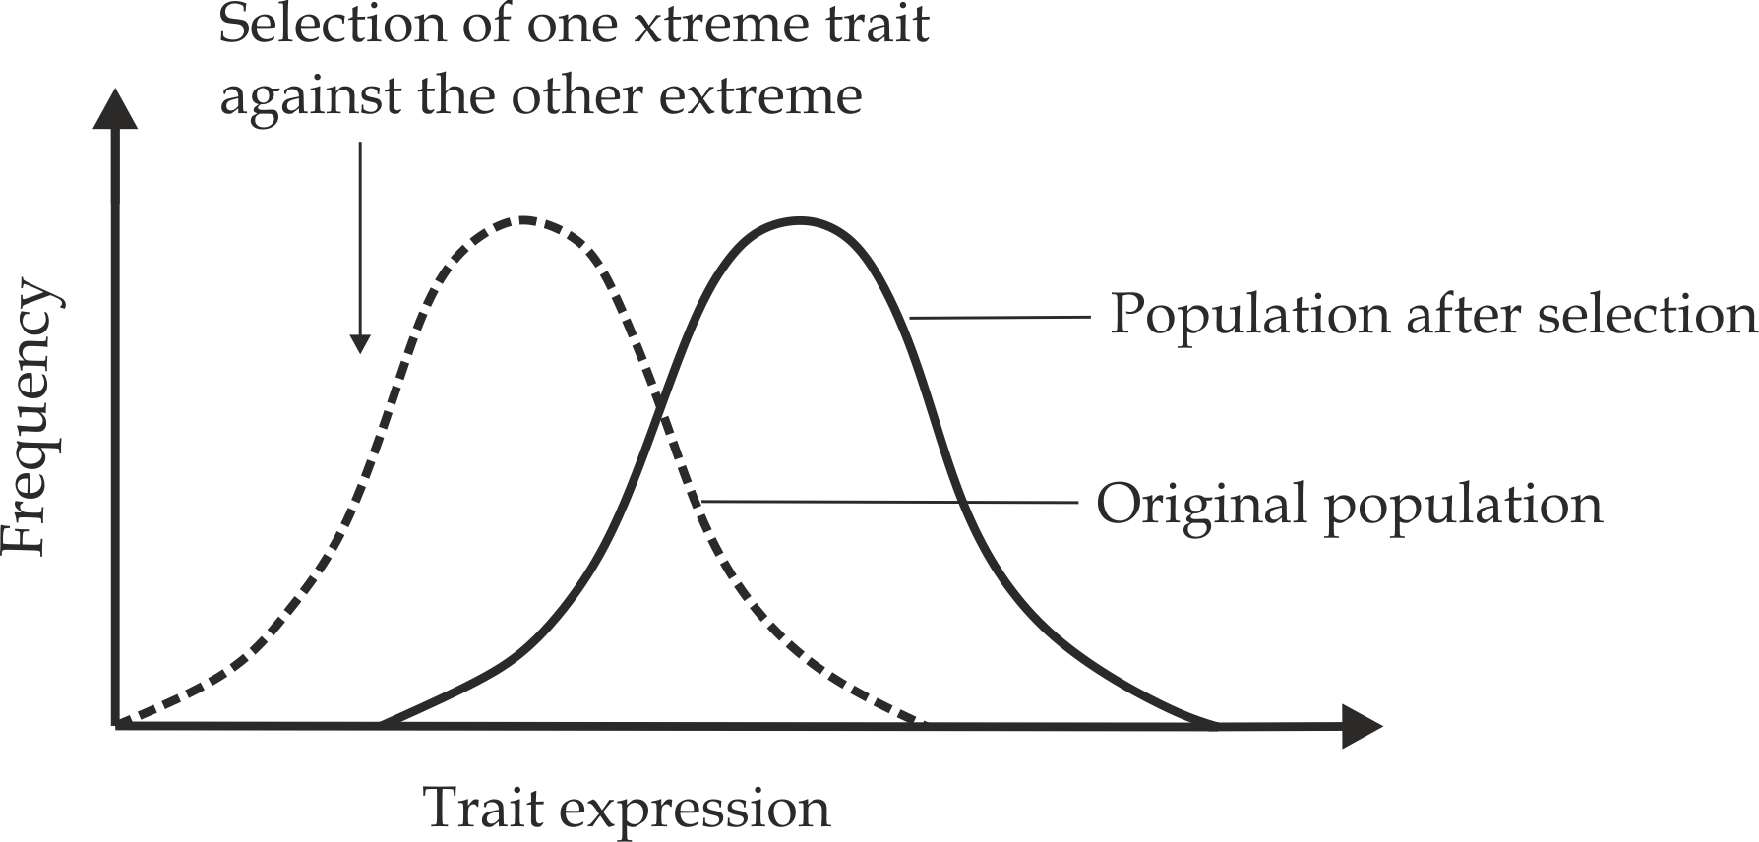

**Fig 5.20** the effect of directional selection on trait distribution

**Example of directional natural selection**

**Industrial melanism** in *Biston betularia* (peppered moths) Fig 5.21 is one of the best evidence for directional natural selection. This instance was recorded by a scientist called **H.B .Kettlewell** in 1959.In UK peppered moths exist in two(2) distinct forms, the white (light) form and black(dark) form, they usually live on the barks of trees that offer them camouflage against predators (birds), due to industrial pollution during industrial pollution during industrial revolution in 19th century, tree barks were blackened with soot, the dark form moths had selective advantage over the white forms against predators as the result the dark form adapted better to survive and pass their traits to the next generation, thus new species evolved.

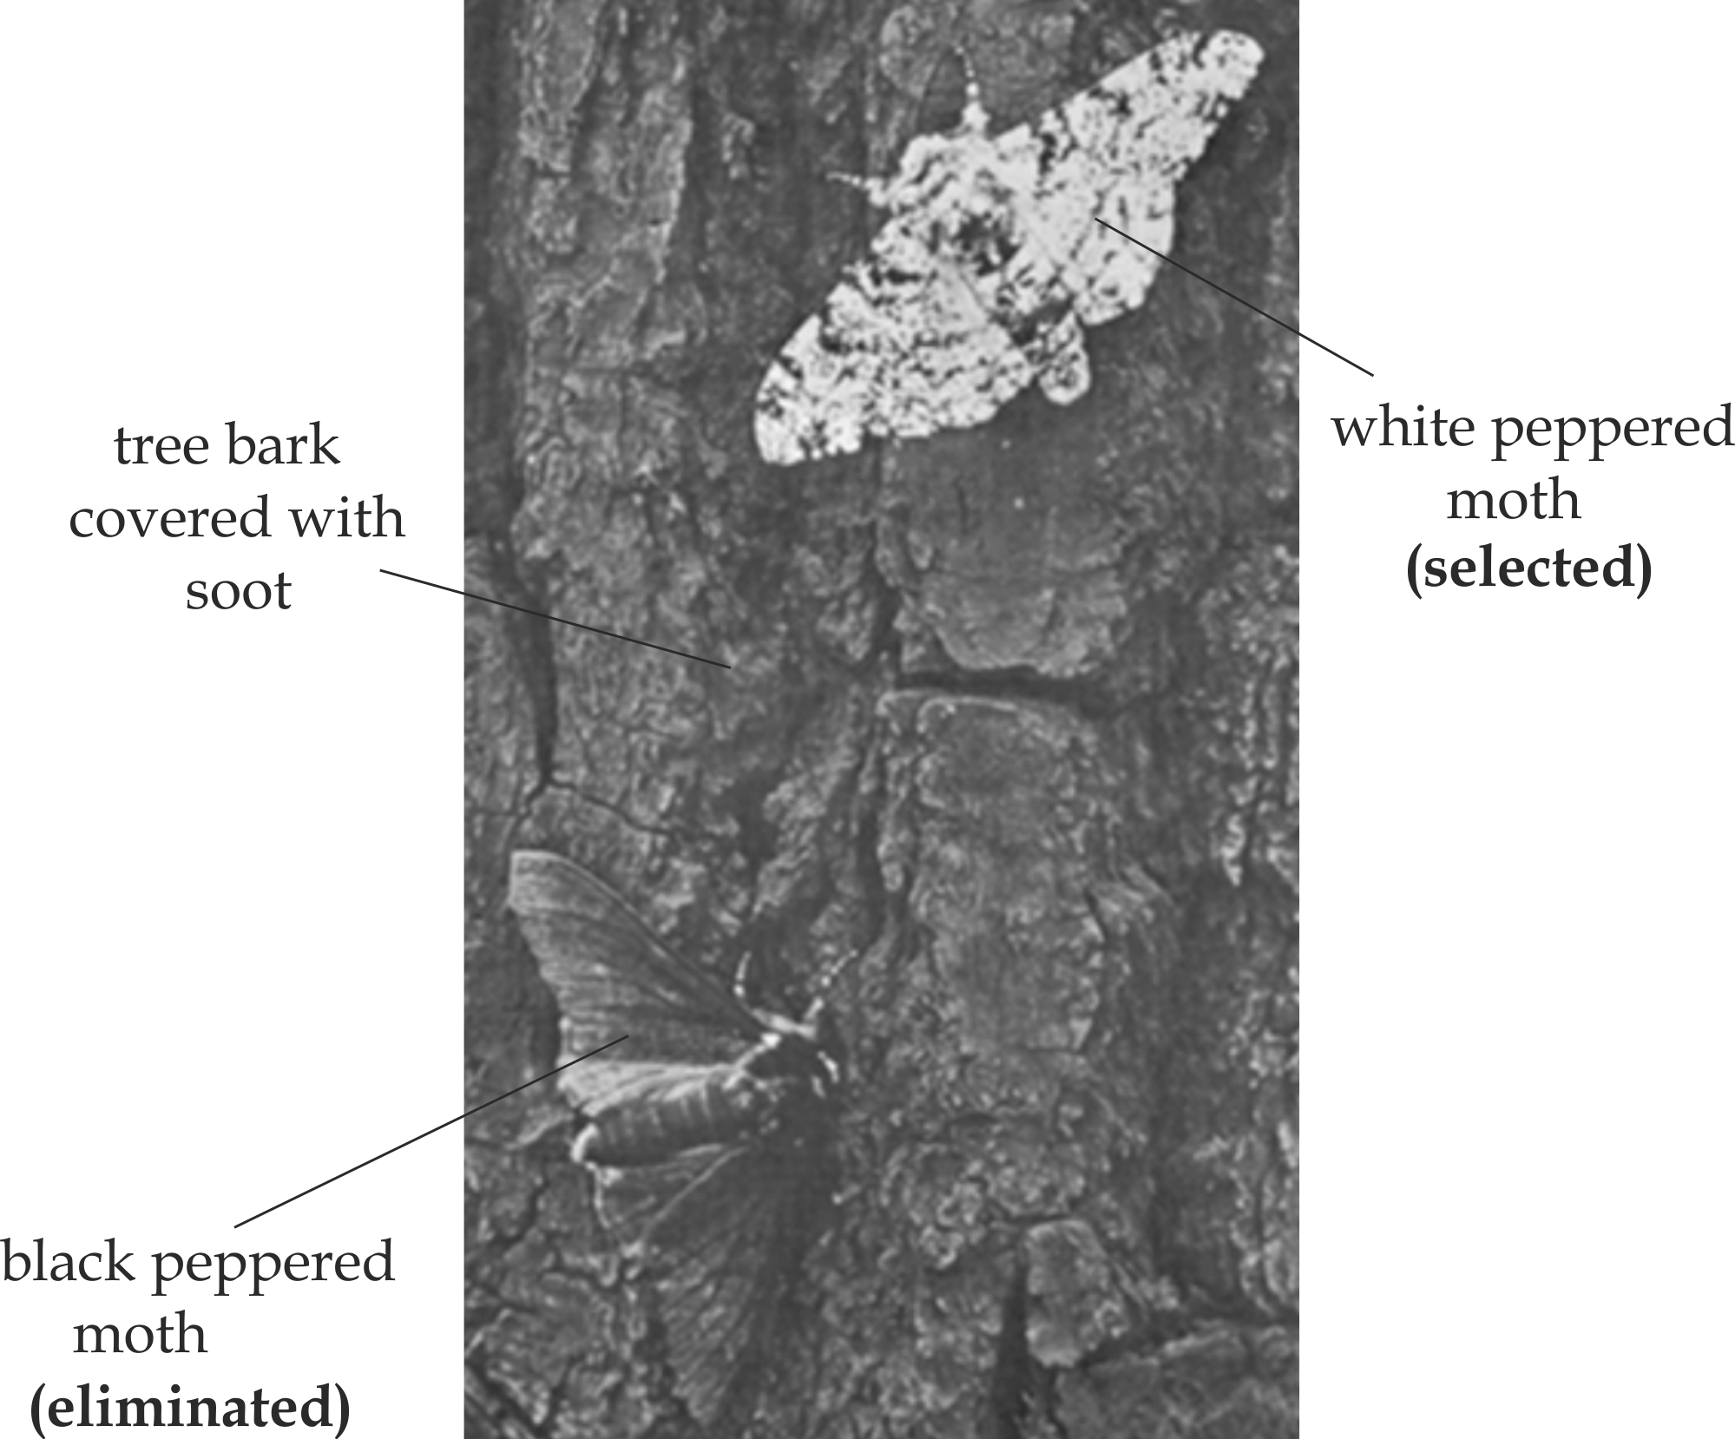

**Fig 5.21** Dark and light coloured Biston betularia moths

**Study tips**

Organisms that exist in two forms in significant numbers are examples of **polymorphism,** one form is gradually being replaced by another. The peppered moth, Biston betularia, is an example of polymorphism for it exists both in speckled white form and in a darkened or **melanic** form. The peppered moth is common in Britain.

**SAQ 5.20**

**TAHOSSA LAKE ZONE 2019**

* Discuss how natural selection works
* Explain the process of natural selection with reference to industrial melanism.i. e, and peppered moth.

1. **Stabilizing natural selection**

It is type of natural selection in which nature select the intermediate traits, in this, more individuals acquire mean character value, so the peak of curve gets higher and narrower Fig 5.21.

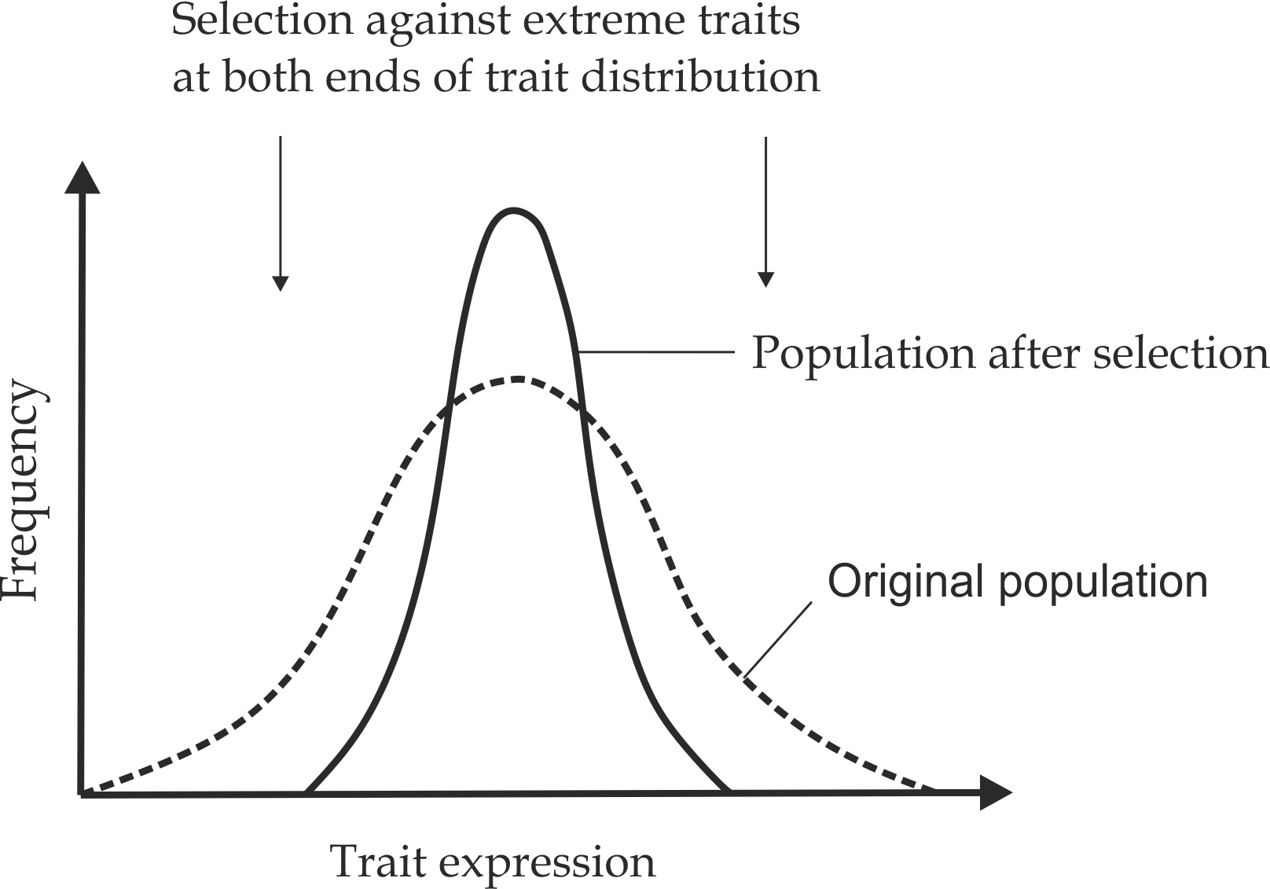

**Fig 5.21** the effect of stabilising selection on trait distribution

**Example of stabilising natural selection**

**Sickle cell anaemia traits** are the one of the best example for stabilising natural selection, in which both normal and anaemic homozygote traits will be selected out. The gene for sickle cell anaemic homozygote “*ss* “is lethal causing death and trait will be selected out, The gene for homozygote normal individuals “ *SS*“ are susceptible to Malaria which may cause death. The genes for heterozygote individuals “Ss “are offer resistance to malaria at the same time are not lethal; therefore heterozygous individuals are the only ones with survival advantage.

**SAQ 5.21**

**TAHOSSA 2012**

* IF malaria were eradicated from the world, explain what you would expect to happen to the frequencies of the sickle cell and normal allele in the human population. What type of selection would cause the change?
* State the advantages of natural selection to organisms

1. **Disruptive selection**

It is a type of natural selection in which the nature selects the extremities traits. This means that the median is not the favoured trait in this case. Instead, both extremes are favoured for survival. However, this is the rarest type of natural selection in a population.

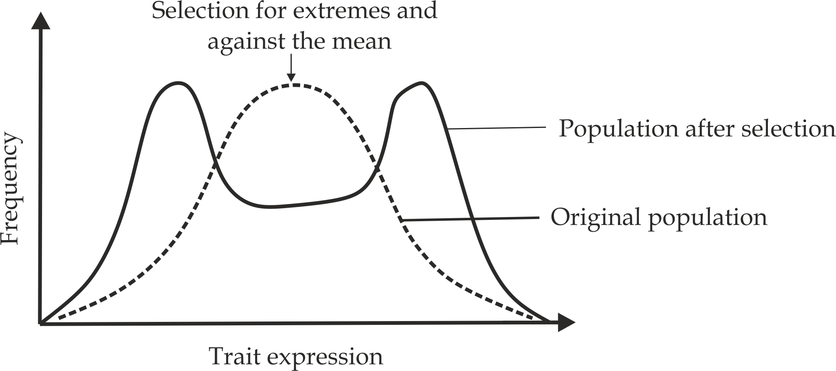

**Example of disruptive natural selection**

For example, in sea, the three types of snails.i.e, white coloured, brown coloured and black coloured are present. The white coloured snails are invisible when rocks are covered by berncles.The black coloured are invisible when rock is bare, but the brown intermediate traits coloured snails are eaten by predators in both conditions, so these are eliminated gradually.

**SAQ 5.22**

**COAST MOCK 2020**

* Define the term natural selection as used in evolution.
* With examples describe the types of natural selection.